Newburgh Enlarged City School District
Response to Intervention
Referral and Information Packet
2017

Revised April 2017
Table of Contents

District Vision/Mission Statement 3
Response To Intervention Definition 4
District RtI Policy 5
The ABC’s of RtI: A Tier 1 7
(Interventions, p. 10, Differentiation p. 12, Tier 1 Behavior, p. 18) B Tier 2 ………………………………………………………………...………23
(Tier 2 Behavior, p. 25)
C Tier 3 ………………………………………………………………………...27
(Tier 3 Behavior, p. 28)
D Tier 4…………………………………………………………………..……..22
Progress Monitoring 30
Reference – How to Document Tier 1 31
Intervention/Tracking Form 32
Steps for Progress Monitoring (NYS Guidance) 34
RtI M Direct 35
Notification to Parents (NYS Guidance) 36
Parent Letter (English) 37
Parent Letter (Spanish) ………………………………………………………………………………...38
RtI Team Meeting Suggestions 39
RtI “20 Minute Meeting” Minutes Protocol 42
RtI “20 Minute Meeting” Minutes Template 43
Suggested RtI Introduction Script 49
Resources 50
Glossary of Terms 52
Appendix A – 3-Tier RtI Model 58
Appendix B – RtI Teacher Referral Form 59
Appendix C – Health Form 62
Appendix D – S.M.A.R.T. Goals 63
Appendix E – RtI Quick Reference Sheet 64
District Vision/Mission Statements

NECSD Vision:
Through the work of all, we will achieve inclusive excellence
NECSD Mission:
Inspiring students to become tomorrow’s leaders beyond Academy Field

Response to Intervention
Response to Intervention (RtI) is the practice of providing high-quality instruction/intervention matched to student needs and using learning rate over time and level of performance to make important educational decisions about an individual student (NASDSE, 2006).
Minimum requirements of a RtI program:
  - appropriate instruction
  - screenings applied to all students
  - instruction matched to student needs
  - repeated assessments of student achievement
  - application of student information to make educational decisions
  - notification to parents
- school district selection of a specific structure and its components
- staff knowledge and skills needed to implement a RtI program
- use of RtI data in determining if a student has a learning disability
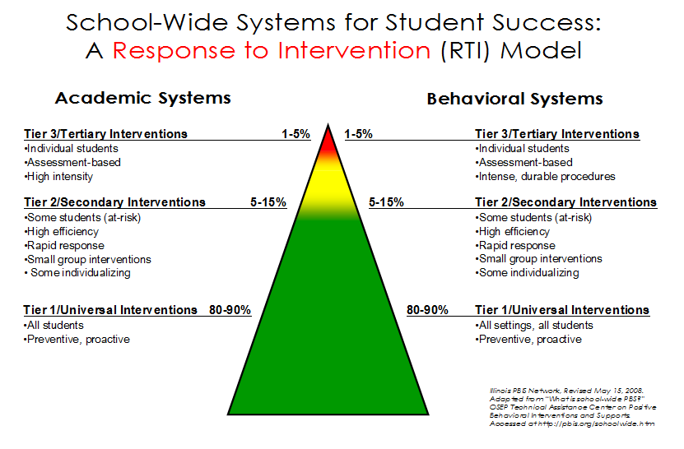
SCHOOL-WIDE PRE-REFERRAL APPROACHES AND INTERVENTIONS
The Board of Education recognizes that the provision of academic and behavioral supports and targeted interventions for students who are not making academic progress at expected levels in the general curriculum may improve a student’s performance, and help avert the need for referral for possible classification as a student with a disability. Therefore, the district will implement on a school-wide basis practices appropriate to enable the district’s students to succeed in the general education environment. These school-wide approaches shall serve as pre-referral interventions prior to consideration of a referral to the Committee on Special Education (CSE). The referral form to the CSE used by District staff will describe, in writing, the intervention services and programs used to remediate the student’s performance, or instructional methodologies, including any supplementary aids or support services provided, or the reasons why no such attempts were made.
The Superintendent or designee will identify and take steps to implement a variety of practices appropriate to comply with this policy. Consistent with applicable law and regulation, those practices may include, for example:
- Providing early intervention services with funds available under the IDEA and which may be coordinated with similar activities conducted under the Elementary and Secondary Education Act. Such services would be made available to students not currently identified as needing special education and related services, but who need additional support to succeed in a general education setting. This may include professional development that enables teachers and other staff to deliver scientifically based academic instruction and behavioral interventions, such as scientifically based literacy instruction and, where appropriate, instruction on the use of adaptive and instructional software. It also may include educational and behavioral evaluations, services and supports.
- Implementation of a Response to Intervention (RtI) program that includes at least the minimum requirements established by Commissioner’s Regulations, and allows teachers and other staff to determine whether a student responds to scientific, research-based instruction or requires interventions beyond those provided to students in the general education classroom.
- Providing academic intervention services (AIS) to students at risk of not meeting the state learning standards in accordance with the District’s plan for AIS. Such services may include additional instruction supplementing instruction in the general curriculum and/or student support services such as guidance, counseling, attendance and study skills needed to support improved academic performance.
- Providing educational related support services (ERSS) such as curriculum and instructional modification services, direct student support teams services, and assessment and non-career counseling services.
- Implementation of a positive behavioral system that reduces school and classroom behavioral problems, and creates and maintains a safe and positive learning environment by promoting positive behavior in all students. These services may be provided before, during or after the school day, or in the summer.
District implementation of any of the above practices will not impede or delay the appropriate evaluation of a student suspected of having a disability, and the student’s right to a free appropriate public education.
Cross-ref: 4000, Student Learning Objectives and Instructional Goals 4325, Academic Intervention Services
Ref: Individuals with Disabilities Education Act §§ 1413(f); 1414(b)(6)(B) 34 CFR §§ 300.226; 300.307(a)(2) 8 NYCRR §§ 100.2(ii); 200.2(b)(7)

4321.2 Adopted: August 23, 2016
The ABCs of RtI:
RtI logic assumes that a student who begins to struggle in general education is typical, and that it is general education’s responsibility to find the instructional strategies that will unlock the student’s learning potential. Only when the student shows through well-documented interventions that he or she has “failed to respond to intervention” does RtI begin to investigate the possibility that the student may have a learning disability or other special education condition.
“Effective July 1, 2012, all school districts in New York State must have a Response to Intervention (RtI) Program in place as part of its evaluation process to determine if a student in grade K – 4 is a student with a learning disability in the area of reading” (NYSED, 2009). The Newburgh Enlarged City School District has made a commitment to the implementation of tiered interventions for reading at the K-5 level.
- Tier 1

Core/Tier 1 instruction and intervention begin at the classroom level. Tier 1 instruction is universal, is available to all students, is delivered within the classroom and includes an ongoing process of developing strong classroom instructional practices. It includes a balanced instructional program, focusing on the motivation to read: phonemic awareness; phonics; vocabulary; comprehension and fluency.

- Core Instruction: Instructional strategies that are used routinely with all students in a general education setting are considered “core instruction.” High- quality instruction is essential and forms the foundation of RtI academic support.

NOTE: While it is important to verify that a struggling student received good core instructional practices, those routine practices do not “count” as individual student interventions.

Core Instruction addresses the question: Are strong classroom instructional strategies sufficient to help the student achieve academic success?

- Intervention: An academic intervention is a strategy used to teach a new skill, build fluency in a skill, or encourage a child to apply an existing skill to new situations or settings. An intervention can be thought of as “a set of actions, that, when taken, have demonstrated ability to change a fixed educational trajectory” (Methe & Riley-Tillman, 2008, p. 37).

Tier 1 intervention targets “red flag” students who are not successful with core instruction alone, uses “evidence-based” strategies to address student academic or behavioral concerns and is feasible to implement given the resources in the classroom.

Tier 1 addresses the question: Does the student make adequate progress when the instructor uses specific academic or behavioral strategies matched to the presenting concerns?
Any intervention should include four essential elements:

- A clearly defined problem.
- Baseline data.
- A performance goal.
- Progress monitoring plan.
What does Tier 1 look like in a K-5 classroom?

- All students receive explicit Common Core Aligned, research-based instruction.

- All classroom teachers provide Tier 1 interventions as needed. Teachers identify struggling students through benchmarks, classroom assessments, and student work.

- Instructional practices are culturally and linguistically responsive.

- Universal screenings are used to determine students’ current level of performance. The whole class is given a reading assessment at the beginning of the year to identify those who may be at risk for low learning outcomes.

- Students who are identified as needing additional support will receive interventions during instruction according to targeted need and data. This occurs in the classroom.

- Teachers problem solve to identify interventions, as needed, to address behavior problems
that prevent students from demonstrating the academic skills they possess. This can occur during common grade level meetings.

- Classroom teachers differentiate the lessons to meet the needs of every student.
Differentiated learning activities (e.g., mixed instructional grouping, use of
learning centers, peer tutoring) are used to address individual needs.

- When students are identified as in need of additional support within the classroom setting:
- Teachers provide instruction with strategies specific to skill needs (this can be group or individual).
- Teachers track the intervention through progress monitoring.
- Teachers use the data to continue the strategies or change the intervention.
- Interventions typically run from 4 – 6 weeks per intervention.

- At Tier 1, classroom teachers are the interventionists. Tier 1 has four components, high quality classroom instruction, differentiation, targeted support, and progress monitoring.

- Tier 1 supports include, but not limited to, small group skills lessons, individual support, strategy instruction (academic checklists, Click or Clunk, choral reading; cooperative learning activities, chunking, editing toolkits; Frayer Model, graphic organizers, pre-reading activities, reading journals, repeated reading, scaffolding, Think-Pair- Share, visualization activities, vocabulary logs, word banks).

- Classroom teachers maintain documentation that shows the student’s strengths and weaknesses and what supports and interventions where put in place to assist the student. The documentation should include formative assessments, benchmarks, progress monitoring data, and anecdotal notes.

According to NYS RtI, “A school district's process to determine if a student responds to scientific, research-based instruction shall include appropriate instruction delivered to all students in the general education class by qualified personnel. Appropriate instruction in reading means scientific research-based reading programs that include explicit and systematic instruction in phonemic awareness, phonics, vocabulary development, reading fluency (including oral reading skills) and reading comprehension strategies. [8 NYCRR §100.2(ii)(1)(i)]”
(http://www.p12.nysed.gov/specialed/RTI/guidance/appropriate.htm#ftn1)
Tier 1 – Consists of quality core instruction and differentiation, scaffolding, small group, or individual instruction based on need. The following suggestions can be used whole group or small group as needed. Tier 1 is intended to help the students become successful in the core curriculum. (This is a sample list and not limited to the items below).
Phonemic Awareness
Skill | Try
Rhymes | Use audio of songs, sing songs
Blend Syllables | Tap words, parts of words
Segment Syllables | Word, syllable counting, clap hands, march in place
Blending | Sound synthesis: “It starts with “ x” and ends with “y”, guessing games
Sound segmentation | Sound to word matching
Sound position (initial, medial, final) | What sound starts the word? What sound ends the word? I Spy (look for items around the room with the sound)
Letter-sound association | Magnetic letters, tiles
Word-to-word matching | Join domino word cards, sound bingo, picture match
Identify phonemes in words | Name picture cards
Sound changes | Change the (letter/ sound here) to a (new letter/sound) say the new word

Phonics
Decoding | Magnetic letters, segment, blend words
Word parts | Teach prefixes, suffixes, root words
Letter Recognition | Letter match
Letter sound correspondence | Letter-sound dominoes
Onset and Rime | Blend onsets and rimes to make new words
Blend sounds of letters to make words | Letter tiles, letter cubes, magnetic letters
Sight Words | Flash cards, cloze activities, fill in the sentence with missing words, find the word games, bingo, word walls
Silent “e” | Word games with short/long vowels

Fluency
Read fluently | Listen to stories on tape (computer), partner read, chunking of the text.  Read Poems  Repeated Reading
Increase words per minute | High frequency word cards, fast words
Use correct phrasing, intonation, and expression in connected text | Sentence strips, Reader’s Theater, listen to passages on computer  Read text that has been divided into chunks  Read target words and connected text

Vocabulary
Identify words in context | Vocabulary cards, sentence strips
Meaning | Word match games, vocabulary logs/journals, context clues, visual representations, cover-copy-compare
Word structure | Word sorts, categorization activities
Words in sentences | Cloze activities

Comprehension
Understanding text | Picture cards and sentence strips, make predictions, create and answer questions, use question cards, predicting, retelling
Activate prior knowledge | KWL chart
Details in text | Chunking, scaffolding, graphic organizers
Character identification | Webs, graphic organizers
Cause/Effect | Card sorts, graphic organizers, if/ then activities
Compare/Contrast | Graphic organizers
Inferences | Match the clue activities, card sorts
Author’s Purpose | Think-Pair-Share
Main idea | Repeated reading, graphic organizers, chunking text
Summarize text | Chunk passage, graphic organizers, before, during, after questioning, retell strategies

Differentiation
Teachers can differentiate content, process, and/or product for students (Tomlinson, 1999). Differentiation of content refers to a change in the material being learned by a student. For example, if the classroom objective is for all students to subtract using renaming, some of the students may learn to subtract two-digit numbers, while others may learn to subtract larger numbers in the context of word problems. Differentiation of process refers to the way in which a student accesses material. One student may explore a learning center, while another student collects information from the web. Differentiation of product refers to the way in which a student shows what he or she has learned. For example, to demonstrate understanding of a geometric concept, one student may solve a problem set, while another builds a model. (http://www.readingrockets.org/article/differentiated-instruction-reading).
The information below is adapted from ReadWriteThink - http://www.readwritethink.org/professional-development/strategy-guides/differentiating-reading-experience-students-30103.html#strategy-practice
- Flexible Grouping: Would we want to homogenously group students by interest and provide a different article to each group? Would we want to homogenously group students by readiness and provide an article in their own zone of proximal development? Would we want to group students homogenously according to learning profiles and the product to be created with the use of the text? Flexible grouping can be a tool to differentiate reading based on student needs and, at one time or another, we'd want to use one of the above options.
- Tiered Texts: Texts can be difficult for students due to a variety of reasons but we can intentionally provide them with more difficult or more manageable texts depending on their prior knowledge, interest, readiness, etc. Using the above example, could we give a group of students who show a difficulty reading at level texts a copy of a Chicago Sun-Times article that includes a summary of events box and uses less density of text? Could we ask another group of students with higher interest or higher readiness to read the actual Chicago City Council proposition? If we think about matching our student needs with the texts, using tiered texts offers numerous possibilities.
- Flexible Use of Strategy/Skill: Literacy research suggests that effective readers use an array of thinking skills before they read a text, while they're reading a text and after they read a text. Reading strategies can draw student attention to specific types of thinking while they read and scaffold his or her ability to use strategies independently. What we want students to do with a text often coincides with the reading strategy that we provide them, the specific reading skills that will be challenged the most in the text and the reading habits of students. But, not every student needs to focus on the same skill (i.e. using context clues with unfamiliar vocabulary) while they read. Instead, we can use a think-aloud to model habits of mind while reading and then provide students with a choice of reading strategies to reinforce these skills.

What is Differentiation?
The idea of differentiating instruction is an approach to teaching that advocates active planning for and attention to student differences in classrooms, in the context of high quality curriculum. (C. Tomlinson, 2010)
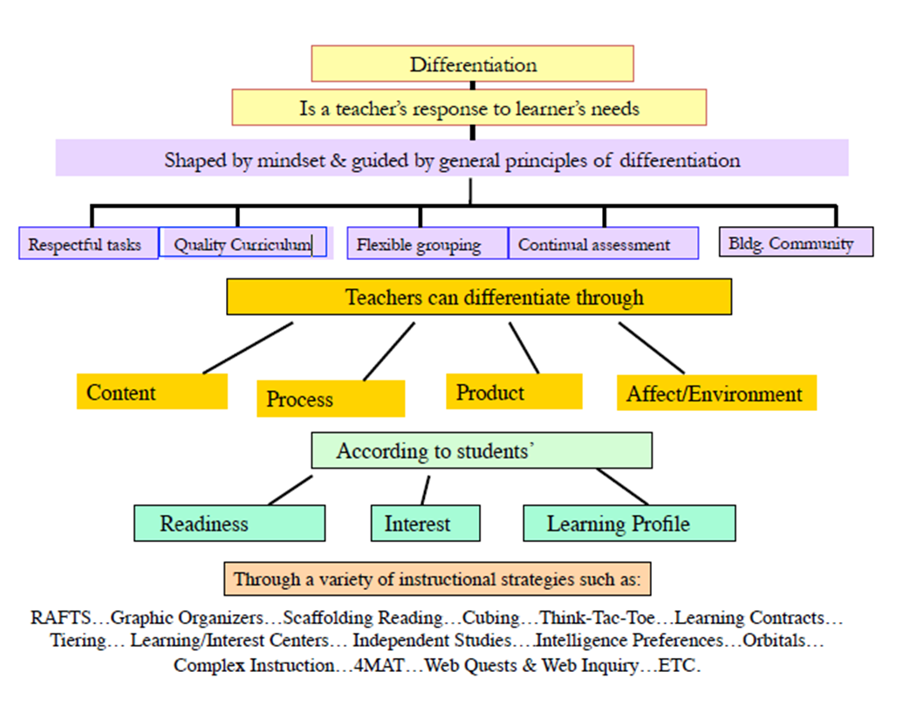
C.Tomlinson,www.caroltomlinson.com/2010SpringASCD/Rex_SAstrategies.pdf

Strategies for Differentiating Content
(Adapted from: The Differentiated Classroom, C. Tomlinson)
Student Characteristics | Strategy
Readiness | Provide texts at varied reading levels.  Provide supplementary materials at varied reading levels.  Reteach for students having difficulty.  Offer extended teaching groups for advanced students.  Demonstrate ideas or skills in addition to talking about them.  Provide audiotaped materials.  Use videotapes to supplement and support explanations and lectures.  Use texts with key portions highlighted.  Use reading buddies or reading partners to work on text or supplementary materials.  Provide organizers to guide note-taking.  Provide key vocabulary lists for reference during note-taking.
Interest | Provide interest centers to encourage further exploration of topics.  Provide a wide range of materials on a wide range of related student interests.  Use student questions and topics to guide lectures and materials selection.  Use examples and illustrations based on student interest.
Learning Profile | Present in visual, auditory, and kinesthetic modes.  Use applications, examples, and illustration from a wide range of intelligences.  Use applications, examples, and illustration from a range of cultures and communities.  Teach with whole-to-part and part-to- whole approaches.  Use wait time to allow for student reflection.

Strategies for Differentiating Process
(Adapted from: The Differentiated Classroom, C. Tomlinson)

Student Characteristics | Strategy
Readiness | Use tiered activities (activities at different levels of difficulty, but focused on the same key learning goal).  Make task directions more detailed and specific for some learners and more open for others.  Provide resource materials at varied levels of readability and sophistication.  Provide teacher-led mini-workshops on varied skill at varied levels of complexity to support student work.  Use a variety of criteria for success, based on whole-class requirements as well as individual student readiness needs.  Provide materials in the primary language of second language learners.  Provide readiness-based homework assignments.  Vary the pacing of student work.
Interest | Use interest-based work groups and discussion groups.  Use both like-interest and mixed interest work groups.  Use the Jigsaw cooperative strategy to allow students to specialize in aspects of a topic that they find interesting.  Design tasks that require multiple interests for successful completion.  Encourage students to design or participate in the design of some tasks.
Learning Profile | Allow multiple options for how students express learning.  Encourage students to work together or independently.  Develop activities that seek multiple perspectives on topics and issues.

Strategies for Differentiating Products
(Adapted from: The Differentiated Classroom, C. Tomlinson)

Student Characteristics | Strategy
Readiness | Use tiered product assignments.  Provide bookmarked internet sites at different levels of complexity for research sources.  Use similar readiness critique groups during product development.  Develop rubrics or other benchmarks for success based on both grade-level expectation and individual student learning needs.
Interest | Encourage students to demonstrate key knowledge, understanding, and skills in related topics of special interest.  Help students find mentors to guide product development of choice of products.  Allow students to use a range of media or formats to express their knowledge, understanding, and skill.  Provide opportunities for students to develop independent inquiries with appropriate teacher or mentor guidance.
Learning Profile | Encourage students to work independently or with partner (s) on product development.  Teach students how to use a wide range of product formats.  Provide visual, auditory, and kinesthetic product options.  Provide analytic, creative, and practical product options.  Ensure connections between product assignments and a range of student cultures/communities.

Differentiated Instruction

Differentiated instruction IS: | Differentiated instruction IS NOT:
Using assessment data to plan instruction and group students | Using only whole class instruction
Teaching targeted small groups | Using small groups that never change
Using flexible grouping (changing group membership based on student progress, interests and needs | Using the same reading text with all students without considering student needs
Matching instructional materials to student ability | Using the same independent seatwork assignments for the entire class without considering student needs
Tailoring instruction to address student needs
(Texas Education Agency, UT-Austin, Vaughn Gross Center (2003). 3-Tier Reading Model.)

Tier 1 Behavior

The goal of RtI Behavior at the Tier 1 level is the prevention of problem behavior and promotion of positive behavior by establishing processes that should facilitate success for 80% of students. An effective Tier 1 system should reduce the number of students who need more expensive and time consuming resources at Tiers 2 and 3. So, if more than 80% of students respond to Tier 1 supports, the school has maximized their resources and is able to meet the needs of more students more effectively.

The Basics of Behavior Support at Tier I

- Form a comprehensive School-wide Behavior Team.
- Develop the school-wide behavior plan and provide training.
- Organize your school-wide behavior data system.
- Schedule monthly team meetings to analyze behavior data and problem solve.

Tier 1 Support Primary Prevention
Tier 1 Universal Supports, Primary Prevention. Preventing the development of new (incidence) problem behaviors by implementing high quality learning environments for all students and staff and across all settings (i.e., school-wide, classroom, and non-classroom).
1. We can effectively teach appropriate behavior to all children. All practices are founded on the assumption and belief that all children can exhibit appropriate behavior. As a result, it is our responsibility to identify the contextual setting events and environmental conditions that enable exhibition of appropriate behavior. We then must determine the means and systems to provide those resources.
2. Intervene early. It is best practices to intervene before targeted behaviors occur. If we intervene before problematic behaviors escalate, the interventions are much more manageable. Highly effective universal interventions in the early stages of implementation which are informed by time sensitive continuous progress monitoring, enjoy strong empirical support for their effectiveness with at-risk students.
3. Use of a multi-tier model of service delivery. Positive Behavior Intervention Support uses an efficient, needs-driven resource deployment system to match behavioral resources with student need. To achieve high rates of student success for all students, instruction in the schools must be differentiated in both nature and intensity. To efficiently differentiate behavioral instruction for all students. PBIS uses tiered models of service delivery.
4. Use research-based, scientifically validated interventions to the extent available. No Child Left Behind requires the use of scientifically based curricula and interventions. The purpose of this requirement is to ensure that students are exposed to curriculum and teaching that has demonstrated effectiveness for the type of student and the setting. Research-based, scientifically validated interventions provide our best opportunity at implementing strategies that will be effective for a large majority of students.
5. Monitor student progress to inform interventions. The only method to determine if a student is improving is to monitor the student's progress. The use of assessments that can be collected frequently and that are sensitive to small changes in student behavior is recommended. Determining the effectiveness (or lack of) an intervention early is important to maximize the impact of that intervention for the student.
6. Use data to make decisions. A data-based decision regarding student response to the interventions is central to positive behavior practices. Decisions in practices are based on professional judgment informed directly by student office discipline referral data and performance data. This principle requires that ongoing data collection systems are in place and that resulting data are used to make informed behavioral intervention planning decisions.
7. Use assessment for three different purposes. There are three types of assessments are used:
1) Screening of data comparison per day per month for total office discipline referrals,
2) Diagnostic determination of data by time of day, problem behavior, and location and
3) Progress monitoring to determine if the behavioral interventions are producing the desired effects.
Tier 1 support is significant in that it moves the structural framework of each educational unit from reactive approaches to proactive systems change performance. This effort cohesively unites all the adults in using 1) common language, 2) common practices, and 3) consistent application of positive and negative reinforcement. There are many caveats to the training, planning, and implementation of PBIS. Just a few of the features are listed below:
Behavioral Expectations
Tier 1 supports of positive behavioral interventions and supports consists of rules, routines, and physical arrangements that are developed and taught by school staff to prevent initial occurrences of behavior the school would like to target for change. For example, a school team may determine that disrespect for self, others, and property is a set of behaviors they would like to target for change. They may choose the positive reframing of that behavior and make that one of their behavioral expectations. Respect Yourself, Others, and Property would be one of their behavioral expectations. Research indicates that 3-5 behavioral expectations that are positively stated, easy to remember, and significant to the climate are best. At the end of the year, a researcher should be able to walk into the school and ask ten random students to name the behavioral expectations and 80% or better of the students should be able to tell the researcher what they are and give examples of what they look like in action.
Behavior expectation examples (see Sample Behavior Expectations under student) http://www.pbis.org/training/staff/student
Labeling Appropriate Behavior in Actions
The school team would then build a matrix (graph) listing the behavioral expectation in a horizontal row. There would be column labels above the behavioral expectations listing all the areas in the school where this behavior could be: 1) taught, 2) modeled, 3) practiced, and 4) observed. For example, in a middle school the columns might include: 1) commons area, 2) cafeteria, 3) gymnasium, 4) bus, 5) hallway, 6) restroom, and 7) sidewalks. The building leadership team would choose two or three examples of what respecting self, others, and property would look like in each of these areas. For example, respecting property in the bathroom would be to "Use the amount of paper towels needed. A good amount would be two." Another example of showing respect for others in the bathroom might include "Be sure to flush the toilet when finished." Similarly, within each classroom, teachers would create their own matrix with classroom routines used as column labels. For example, in a middle school classroom, routines might include: 1) entering/exiting classroom, 2) teacher-lead instruction, 3) collaborative-group work, 4) independent work, and 5) transitions. Each teacher (or teachers in grade-level or department teams) would select two or three examples of what respecting self, others, and property would look like within each routine. For example, respecting self when transitioning may look like 1) checking the smart board for instructions, 2) getting the needed materials, and 3) quickly and quietly shifting between tasks, activities, or locations.
Matrix examples (see Sample Matrices and Guidelines under student) http://www.pbis.org/training/staff/student
Teaching Appropriate Behavioral Actions
The building leadership team would then decide how they were going to teach these behaviors to the students. Some schools choose to have stations and rotate all the children through various locations where the adults act out the appropriate behaviors relevant to each area. Some schools choose to show a non-example first and then the appropriate example last. After adults model the appropriate behavior, students emulate the new behavior before they rotate to the next learning station. Adults give feedback to the students on their performance during the training, to alleviate any misrules they may begin. For example, some schools place hula hoops on the floor in front of the entrance to the cafeteria tray area. Adults model for students that only one person stands in each hula hoop and the line only advances as a hula hoop becomes empty. The hula hoops allow the children to visualize personal space better than just telling them "don't push and crowd". In addition, each teacher explicitly teaches students how to engage in expected behavior within each classroom routine. For example, a teacher may explain how to be respectful during cooperative group work, ask a group of students (who have been pre-taught) to model respect during a role-played cooperative group, play a quick thumbs up/down game to have students identify examples/non-examples of expected behavior, and then assign students a cooperative group work assignment and monitor students’ behavior. While monitoring, the teacher can provide immediate feedback to students who are and are not engaging in respectful behavior and quickly take data to assess how well students’ responded to the instruction.
Lesson plan examples (see Lesson Plans under student) http://www.pbis.org/training/staff/student
Observing and Praising Appropriate Behavioral Actions
The building leadership team would also determine how they intended to "catch" students exhibiting the appropriate behaviors. Specific praise is extremely important in increasing the reoccurrence of appropriate behavior. Some schools decide to give out small pieces of paper labeled as "Gotchas". All staff hand the “Gotchas” with specific praise to students as they witness appropriate behaviors in the common areas. Within classrooms, teachers would also use specific praise to recognize students engaging in expected behaviors within classroom routines. If the school has adopted a “Gotcha”, ticket, or token system, the teacher would also incorporate that system into his or her classroom to recognize appropriate student behavior.
“Gotcha” resource (see Gotcha Resources - Gotcha reward schedules, free rewards for students- etc. under student) http://www.pbis.org/training/staff/student
Conclusion
These are just a few examples of the procedures and practices that occur during the initial training for Tier 1 support. Precise facets of the training make it specific to each building. The important features are:
1) Most schools realize similar results;
2) Implementation looks completely different at each site, based on the needs of their specific unit and,
3) Ongoing decisions are made based on data driven results.

It goes without saying that we want to prevent the major "upsurges in targeted behaviors" that we hear about in the news: violent acts against teachers or other students, theft, bullying behavior, drug use, and the like. However, research has taught us that efforts to prevent these serious problems are more successful if the "host environment"—the school as a whole—supports the adoption and use of evidence-based practices. Practices that meet these criteria include teaching and rewarding students for complying with a small set of basic rules for conduct, such as "be safe," be responsible," and "be respectful." These rules translate into sets of expectations that differ according to various settings in the school. Thus, on the playground "be safe" means stay within boundaries and follow the rules of the game. In hallways and on stairs, it means to keep your hands and feet to yourself and to walk on the right side. Some parents and educators believe that students come to school knowing these rules of conduct, and that those who don't follow them simply should be punished. However, research and experience has taught us that systematically teaching behavioral expectations and rewarding students for following them is a much more positive approach than waiting for misbehavior to occur before responding. It also establishes a climate in which appropriate behavior is the norm. Finally, the use of Tier 1 support strategies has been shown to result in dramatic reductions in the number of students being sent to the office for discipline in elementary and middle schools across the United States and Canada. In effect, by teaching and encouraging positive student behavior (i.e., positive behavior intervention and support), we reduce the "white noise" of common but constant student disruption that distracts us from focusing intervention expertise on the more serious problems mentioned above.
Tier 1 support, through positive behavior support, works for over 80% of all students in a given school (based on a criterion of the number of students who have one or fewer office discipline referrals per month). But obviously, no intervention works across the board for all students. For a variety of reasons, some students do not respond to the kinds of efforts that make up Tier 1 support, just as some children do not respond to initial teaching of academic subjects. Some children need booster shots and some children need intensive interventions.
Putting into place systematic Tier 1 support strategies offers two advantages: First, it reduces the "water torture" caused by large numbers of office discipline referrals for minor problems. As we suggested earlier, this volume of referrals obscures and distracts our attention from more serious problems. Second, having a system for documenting the occurrence of targeted behaviors (e.g., office discipline referrals) provides a way to determine which students need more intensive intervention. For example, the criterion for considering the need for moving into secondary prevention for a student or group of students might be 4 or more office discipline referrals in a month. Without Tier 1 support, of course, the number of students meeting these criteria and needing additional help will be much larger. (pbis.org)

- Tier 2

Tier 2 is group based, supplemental, not all students participate, and is closely aligned to Academic Intervention Services. When Tier 1 interventions do not result in adequate student progress, Tier 2 interventions are necessary. This supplemental instructional intervention is provided in addition to, and not in place of, the core instruction provided in Tier 1. For example, a student who is receiving Tier 2 intervention would be provided core instruction plus 30 minutes of supplemental interventions three to five days per week in small homogeneous groups.
Tier 2 interventions focus on the areas of student need or weakness that are identified in the screening, assessments, or progress monitoring reports from Tier 1. Therefore, students are often grouped according to instructional need. Interventions at Tier 2 can last between 9 – 30 weeks. Tier 1 intervention in the general education classroom continues to be provided by the classroom teacher while Tier 2 interventions are taking place outside of the classroom instruction. (http://www.p12.nysed.gov/specialed/RTI/guidance/instruction.htm)

A decision to move to Tier 2 interventions is made based on assessment data (progress monitoring, benchmarks, et. al.). A student can receive Tier 2 interventions by the classroom teacher, AIS provider, or other designated personnel.

- The classroom teacher may implement Tier 2 interventions in the classroom (in addition to regular instruction) or may make a referral to the RtI team. Some student may already be receiving AIS support based on building data decisions.
Note: Referral to the RtI team is made after Tier 1 (or Tier 2) interventions have been implemented and progress monitoring has occurred. Appropriate documentation of the interventions will be provided with the referral form for the referral to proceed.
- At the RtI meeting, decisions will be made regarding research-based interventions aligned to the skill need, who will provide the intervention, and the type and frequency of progress monitoring. The classroom teacher can implement Tier 2 in the classroom as small group instruction. This instruction is provided in addition to classroom instruction during an RtI designated time or another time that fits into the daily schedule (At least 3 times a week for a minimum of 30 minutes per session. Tier 2 does not replace classroom instruction). The teacher will establish small group instruction based on skill need (s) of the student (s).

- Groups can be formed within a classroom or across a grade level as long as the groups are developmentally appropriate.

- Progress Monitoring should be done more frequently than Tier 1, at least bi-weekly to determine whether or not the student is making progress or whether the interventions should be adjusted.

- If an AIS provider has already identified the student for services based on benchmark, state assessments, or universal screening data the classroom teacher will still provide Tier 1 support and documentation. The AIS and the classroom teacher will each be responsible to provide interventions and progress monitoring data at the RtI meeting.

- AIS teachers who have identified students in need of interventions will form groups based on skill need. Interventions and progress monitoring will match the skill. Small group instruction is required at this Tier. It is provided in addition to the classroom instruction. Interventions can be provided in the classroom setting or a separate location. Students can move in and out of Tier 2 based on skill mastery and data evidenced through progress monitoring.

- The cycle for Tier 2 can last anywhere from 9 to 30 weeks. Interventions may be adapted or changed if the student is not showing adequate progress. The decisions to modify the interventions will be made through the RtI Team.

Tier 2 Behavior Support

Tier 2 supplemental supports are designed to provide additional or targeted interventions to support students who have access to Tier 1 Universal Supports but are not responding positively to them. Approximately 5-15% of the students may need Tier 2 supports. However, schools with strong Tier 1 supports will have a reduced need for Tier 2 supports. Supplemental support is designed for use in schools where there are more students needing behavior support than can be supported via intensive and individual Tier 3 support, and for students who are at risk of chronic problem behavior, but for whom high intensity interventions are not essential. Most importantly, students receiving Tier 2 should continue to have full access to Tier 1 supports.

Tier 2 Behavior Support Targeted Support
Tier 2 Targeted Supports, Secondary Prevention
Reducing the number of existing (prevalence) problem behaviors that are presenting high risk behaviors and/or not responsive to primary intervention practices by providing more focused, intensive, and frequent small group-oriented responses in situations where problem behavior is likely.
Positive behavior intervention and support is an application of a behaviorally-based systems approach to enhance the capacity of schools, families, and communities to design effective environments that improve the fit or link between research-validated practices and the environments in which teaching and learning occurs. Attention is focused on creating and sustaining Tier 1 (universal for ALL students), Tier 2 (targeted group support for SOME students), and Tier 3 (individual support for a FEW students) systems of support that improve lifestyle results (personal, health, social, family, work, recreation) for all children and youth by making problem behavior less effective, efficient, and relevant, and desired behavior more functional. (pbis.org)
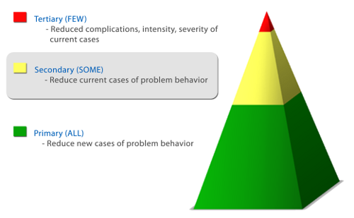

Tier 2 Examples:
- Behavior Contract
- Structured Breaks
- Check In Check Out (CICO)
- Daily Behavior Form
- Individual & Visual Schedules
- Mentoring
- Non-Verbal Cues & Signals
- Organizational Tools
- Peer Tutoring
- Reward System
- Self-Monitoring
- Sensory Tools
- Social Stories
- Teach Conflict Resolution Skills
- Teach Coping Skills
- Teach Relationship Skills
- Teach Relaxation Techniques
- Teach Social Skills
Resources:
Tier II Systems Readiness Guide http://www.pbis.org/resource/1068/tier-2-systems-readiness-guide
Classroom Checklists, Effective Classroom Plan, Environmental Inventory Checklist http://www.pbis.org/resource/192/classroom-checklists-effective-classroom-plan-environmental-inventory-checklist
Classroom Management: Self-Assessment http://www.pbis.org/resource/174/classroom-management-self-assessment-revised-version-april-7-2006
Effective Behavior Support (EBS) Survey (v 2.0) http://www.pbis.org/resource/219/effective-behavior-support-ebs-survey-v-2-0
- Tier 3
The third level of the RTI prevention framework, is the most intensive of the three levels and is individualized to target each student’s area (s) of need. At the tertiary level, the teacher begins with a more intensive version of the intervention program used in secondary prevention (e.g., longer sessions, smaller group size, more frequent sessions). However, the teacher does not presume it will meet the student’s needs. Instead, the teacher conducts frequent progress monitoring (i.e., at least weekly) with each student.
These progress monitoring data quantify the effects of the intervention program by depicting the student’s rate of improvement over time. When the progress monitoring data indicate the student’s rate of progress is unlikely to achieve the established learning goal, the teacher engages in a problem-solving process. That is, the teacher modifies components of the intervention program and continues to employ frequent progress monitoring to evaluate which components enhance the rate of student learning. By continually monitoring and modifying (as needed) each student’s program, the teacher is able to design an effective, individualized instructional program (National Center on Response to Intervention, 2010, p. 11).

Students who are not making adequate progress or who are not responding to Tier 2 level interventions may be moved to Tier 3. The decision will be made during a RtI meeting. Tier 3 is typically reserved for approximately one to five percent of students in a class who will receive more intensive instruction in addition to their core instruction. Tier 3 differs from Tier 2 instruction in terms of such factors as time, duration, group size, frequency of progress monitoring, and focus.
What does Tier 3 look like?

- Tier 3 provides greater individualized instruction in small, homogenous groups (generally one to two students at a time).

- Instruction is provided for 30 – 60 minutes, 5 times per week.
- The progress of students at Tier 3 is monitored more frequently, at least once a week, to determine the student’s response to intervention.

- This level of intervention can be provided by a reading teacher, math specialist or other qualified teacher. Tier 3 is supplemental instruction and does not replace Tier 1 instruction or the Tier 1 supports that still must be provided by the classroom teacher. (www.nysed.gov, 2010).

- The interventions at Tier 3 can last approximately 15-20 weeks.
Note: Tier 3 interventions must be implemented and progress monitored before a request for referrals are made to the Special Education Department. The Tier 3 intervention cycle typically lasts between 15 – 20 weeks.

Tier 3 Behavior Support Intensive Support
Tier 3 Intensive Supports, Tertiary Prevention
Reducing the intensity and/or complexity of existing (prevalence) problem behavior that are resistant to and/or unlikely to be addressed by primary and secondary prevention efforts by providing most individualized responses to situations where problem behavior is likely. (www.pbis.org)
At the tertiary or Tier 3 level, support is provided to the 1-5% of students who may have very serious problem behaviors and may require more intensive and individualized supports. The supports are organized to reduce the frequency, duration, and intensity of externalizing and internalizing problem behaviors and improve life outcomes. (www.pbis.org)
Examples:
- Functional Behavior Assessment (FBA)
- Behavior Intervention Plan (BIP)
- Behavior Meetings
- Behavior Contract

Tier 1 | Universal Supports, Primary Prevention | Preventing the development of new (incidence) problem behaviors by implementing high quality learning environments for all students and staff and across all settings (i.e., school-wide, classroom, and non-classroom).
Tier 2 | Targeted Supports, Secondary Prevention | Reducing the number of existing (prevalence) problem behaviors that are presenting high risk behaviors and/or not responsive to primary intervention practices by providing more focused, intensive, and frequent small group-oriented responses in situations where problem behavior is likely.
Tier 3 | Intensive Supports, Tertiary Prevention | Reducing the intensity and/or complexity of existing (prevalence) problem behavior that are resistant to and/or unlikely to be addressed by primary and secondary prevention efforts by providing most individualized responses to situations where problem behavior is likely.

- Tier 4 Request for a Referral to Special Education
Students who, without a doubt, have not shown progress after Tier 1, Tier 2, and Tier 3 interventions can be reviewed for a request for a Special Education Referral. Prior to the request for a referral, there must be evidence of a Tier 3 RtI meeting where the school psychologist was in attendance.

Once the decision is made to request a Special Education Referral, the following must be adhered to:

- A Tier 4 RtI meeting must be convened.
- The Supervisor of Special Education assigned to the building will be invited to the meeting
- The RtI Specialist will be invited to the meeting

- The Supervisor of Special Education and the RtI Specialist will review the paperwork that accompanies the request. This can be done outside of the RtI meeting.

- The Special Education Supervisor and the RtI specialist will make the determination whether to forward the request for the referral to the Executive Director or return it to the building for additional information.

- The request for referral must include:

- Evidence that the child was in each tier as per SED guidance
- S.M.A.R.T goals
- Progress monitoring
- Data presented in a graph – relative to where the student is and where he/she needs to go
- Specific strategies that were utilized to address the learning gap

Progress Monitoring

Progress Monitoring Within a Response-to-Intervention Model
by Douglas D. Dexter, Ph.D., and Charles Hughes, Ph.D., Penn State University (http://www.rtinetwork.org/learn/research/progress-monitoring-within-a-rti-model)

What Is Progress Monitoring?
In the context of an RTI prevention model, progress monitoring is used to assess student progress or performance in those areas in which they were identified by universal screening as being at-risk for failure (e.g., reading, mathematics, social behavior). It is the method by which teachers or other school personnel determine if students are benefitting appropriately from the typical (e.g., grade level, locally determined, etc.) instructional program, identify students who are not making adequate progress, and help guide the construction of effective intervention programs for students who are not profiting from typical instruction (Fuchs & Stecker, 2003). Although progress monitoring is typically implemented to follow the performance of individual students who are at risk for learning difficulties, it can also follow an entire classroom of students (Fuchs & Fuchs, 2006).

How Does Progress Monitoring Work in RtI?
As soon as a student is identified as at risk for achievement deficits by the universal screening measure, his or her progress should be monitored in relation to Tier 1 instruction (Fletcher, Lyon, Fuchs, & Barnes, 2007). Progress should be monitored frequently, at least monthly, but ideally weekly or biweekly (Fuchs & Fuchs, 2006). A student's progress is measured by comparing his or her expected rate of learning (e.g., local or national norms) and actual rate of learning (Fuchs, Fuchs, & Zumeta, 2008). A teacher can use these measurements to gauge the effectiveness of teaching and to adjust instructional techniques to meet the needs of the individual student. A student who is not responding adequately to Tier 1 instruction moves on to Tier 2 and increasingly intensive levels of intervention and instruction. The current recommended time period for measuring response to Tier 1 instruction is 8–10 weeks (McMaster & Wagner, 2007; Fuchs & Fuchs, 2005; Vaughn, Linan-Thompson, & Hickman, 2003) and non-responsiveness is typically determined by a percentile cut on norm-referenced tests (e.g., < 20th percentile) or cut score on a curriculum based measurement (CBM).
According to the National Center on Student Progress Monitoring, progress monitoring has the following benefits when it is implemented correctly: 1) students learn more quickly because they are receiving more appropriate instruction; 2) teachers make more informed instructional decisions; 3) documentation of student progress is available for accountability purposes; 4) communication improves between families and professionals about student progress; 5) teachers have higher expectations for their students; and, in many cases, 6) there is a decrease in special education referrals. Overall, progress monitoring is relevant for classroom teachers, special educators, and school psychologists alike because the interpretation of this assessment data is vital when making decisions about the adequacy of student progress and formulating effective instructional programs (Fuchs, Compton, Fuchs et al., 2008).
Reference – How to Document Tier 1
(Adapted from Jim Wright – InterventionCentral.org, 2010)
Documenting Tier 1 (Classroom) Interventions

When general-education students begin to struggle with academic or behavioral issues, the classroom teacher will typically select and implement one or more evidence-based intervention strategies to assist those students. But a strong intervention plan needs more than just well-chosen
interventions. It also requires 4 additional components (Witt, VanDerHeyden, & Gilbertson, 2004):

- student concerns should be clearly and specifically defined
- one or more methods of formative assessment should be used to track the effectiveness of the intervention
- baseline student data should be collected prior to the intervention
- a goal for student improvement should be calculated before the start of the intervention to judge whether that intervention is ultimately successful. If a single one of these essential 4 components is missing, the intervention is to be judged as flawed (Witt, VanDerHeyden, & Gilbertson, 2004) and as not meeting minimum RTI standards.

• Definition of up to two students’ academic or behavioral problems. The most significant step in selecting an effective classroom intervention is to correctly identify the target student concern(s) in clear, specific, measureable terms (Bergan, 1995). The teacher selects no more than two student concerns to address on the intervention plan.

• Intervention description. The teacher describes the evidence-based intervention(s) that will be used to address the identified student concern(s).

• Intervention delivery. The teacher writes down details necessary for implementing the intervention in the classroom (e.g., where and when the intervention will be used; the adult-to-student ratio; how frequently the intervention will take place; the length of time each session of the intervention will last; materials needed for the intervention, etc.

• Checkup date. The teacher notes the date at which the intervention will be reviewed to determine whether it has been sufficiently effective.

NOTE: For academic interventions, it is advisable to allow at least 4 - 6 instructional weeks before deciding whether the intervention has been effective.

• Assessment data. For each intervention, the teacher selects the type(s) of classroom data that will be collected formatively throughout the intervention period to judge its effectiveness. For each data source, in turn, the teacher collects baseline data on student performance—and calculates an outcome goal that the student is expected to attain if the intervention is successful. (During the period in which the intervention is in effect, the teacher collects ongoing data to judge student performance and attaches that data to the classroom intervention documentation form).
Newburgh Enlarged City School District
Response to Intervention

Intervention Planning/Tracking Form

This form is used to document Tier 1, Tier 2, or Tier 3 interventions and student progress. A separate form is used for each level of intervention that is being provided. A copy of this document must be added to the referral packet given to the RtI team when a student is referred to the RtI team and provided to the parent when the student is in Tier 2 or Tier 3.

Student: ______________________________________ Teacher: __________________________
School: __________ Grade: _____________ D.O.B._______________
ID#: ___________________ Date: ______________
ELL Student: Yes/No NYSESLAT results _________ Receiving ENL: Yes/No
Principal’s Signature (to acknowledge the RtI referral) _____________________________________________________

Statement of Problem (s) (Clearly define student concerns):
- __________________________________________________________________________________________________________________
- __________________________________________________________________________________________________________________

Level of intervention: Tier 1 Tier 2 Tier 3
Assessment data used to determine academic concern (baseline data):
Type of Assessment | Date Administered | Results

Desired Goal (outcome):
(S.M.A.R.T. Goal)
____________________________________________________________________________________________________________________________
Intervention (s)
Research based intervention | Frequency | Ratio: student to teacher | Dates of intervention (s) | Intervention provider

Progress Monitoring
Name/Type of Formative Assessment:
 | Date of Progress Monitoring | Person providing the intervention (s) | Results | Principal’s Initials
Week 1
Week 2
Week 3
Week 4
Week 5
Week 6
Name/Type of Formative Assessment:

Week 1
Week 2
Week 3
Week 4
Week 5
Week 6
Steps for Progress Monitoring

(http://www.p12.nysed.gov/specialed/RTI/guidance/assessment.htm)
Progress monitoring involves the following steps*:
- Establish a benchmark for performance and plot it on a chart (e.g., “read orally at grade level 40 words per minute by June”). It must be plotted at the projected end of the instructional period, such as the end of the school year.
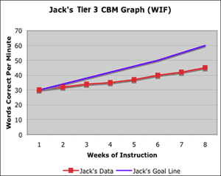
- Establish the student’s current level of performance (e.g., “20 words per minute”).
- Draw an aim line from the student’s current level to the performance benchmark. This picture represents the slope of progress required to meet the benchmark.
- Monitor the student’s progress frequently (e.g., every Monday). Plot the data.
- Analyze the data on a regular basis, applying decision rules (e.g., “the intervention will be changed after six data points that are below the aimline”).
- Draw a trend line to validate that the student’s progress is adequate to meet the goal over time.
Quality Indicators for Progress Monitoring
- Progress monitoring of student performance occurs across all tiers.
- Teachers follow a designated procedure and schedule for progress monitoring.
- Measures are appropriate to the curriculum, grade level and tier level.
- Data from progress monitoring are documented and analyzed.
- A standardized benchmark is used to measure progress and determine progress sufficiency.
- Teachers use progress monitoring to inform instructional effectiveness and the need for changes in instruction or intervention.
- Graphs are used to display data for analysis and decision making.
- Staff receive training in the administration and interpretation of progress monitoring measures and the implications for instruction.
- The district has designated reasonable cut points, and decision rules of the level, slope or percentage of mastery to help determine responsiveness and distinguish adequate from inadequate responsiveness.
- When monitoring the progress of LEP/ELL students, the student’s progress is compared with the levels of progress demonstrated by peers from similar cultural and linguistic backgrounds who have received the interventions.

Data Management
RtI M Direct
RtI M Direct is a full-life cycle software solution for tracking, documenting, monitoring, and managing Response to Intervention (RTI) / Academic Intervention Services (AIS) https://login.frontlineeducation.com/login?signin=3614d97bc799761d835c3d95ca8de5bf&productId=RtiLegacy&clientId=StudentSolutions#/login
The RtI chairperson in each building will be responsible for maintaining the on-line records for all students involved in the RtI process.

Notification to Parents
Parents are to be notified whenever a student enters instruction beyond what is given to the entire class. It is the responsibility of the classroom teacher to notify parents when Tier 1 and Tier 2 interventions are provided by the classroom teacher. It is the responsibility of any additional teacher who provides interventions at Tier 1, 2, and 3 to notify the parent.
(http://www.p12.nysed.gov/specialed/RTI/guidance/parents.htm)
While it is expected that parents are involved and kept informed of their child’s progress in school at all levels, when students participate in the RtI process, there are specific parent notification requirements. Parents must be notified in writing and in a language or mode of communication they understand if their child needs an intervention beyond that which is provided to all students in the classroom in an RtI process. Such parents must specifically be notified in writing:
- how much and what kind of information (data) the school will collect to monitor the student’s progress
- the nature of the intervention/instructional support the student will receive
Quality Indicators for Parent Notification
- General information about the RtI process is provided to all parents.
- The notification to parents when a student needs supplemental intervention includes all required information and is provided in a language the parent understands.
- The nature and frequency of communication between parents and staff is clearly defined.
- The frequency of providing progress monitoring data to parents is adequate and appropriate to ensure they are regularly informed of their child’s progress.

*A template that can be used for parent notification follows. There is one in English and Spanish.
Newburgh Enlarged City School District

Dear Parent/Guardian of: (Name of Student)
In the Newburgh Enlarged City School District we use an instructional model called Response to Intervention (RtI). RtI is instructional support provided to your child to meet his or her learning needs. This research-based instruction is in addition to the regular classroom instruction.
As part of our district-wide efforts to improve student achievement, all students in the elementary grades, K – 5, are given universal screenings three times a year to measure progress over time. Interventions are provided as needed to all students who did not meet expected levels of achievement in reading and/or mathematics. Progress is monitored on a regular basis to check the effectiveness of the interventions.
Your child’s progress has been reviewed and an intervention plan was put in place to assist your child in making successful progress in school. The intervention plan is attached for your review.
Your child is receiving:
- Tier 2 Interventions: Your child is receiving additional instruction in a small group setting. It is being provided by ________________________________.
Your child’s progress will be monitored by the intervention provider and shared with the RtI team.

- Tier 3 Interventions: Your child struggled in Tier 2 so additional supports are being provided in a small group setting (1 to 2 students). Your child will receive more intensive interventions at this level. It is being provided by ________________________________.
Your child’s progress will be monitored by the intervention provider and shared with the RtI team.
- Tier 4 Interventions: Tier 2 and Tier 3 interventions have not been successful; a request will be made for a special education referral. As a parent, you have the right to request an evaluation for special education and/or services.
If you have any questions or concerns, please do not hesitate to contact your child’s teacher.
Sincerely,
Building Principal

Cc: Supervisor of Special Education assigned to building
RtI Chairperson
Classroom Teacher

Estimados Padres/Madres/Guardianes de: __________________
En el Distrito Extendido Escolar de la Ciudad de Newburgh usamos un modelo de instrucción llamado Respuesta a la Intervención (RTI). RTI es un apoyo a la instrucción que se le provee a su hijo/hija para satisfacer sus necesidades de aprendizaje. Esta instrucción basada en la investigación es adicional a la instrucción regular en el salón de clase.
Como parte de nuestros esfuerzos de todo el distrito mejorar el rendimiento de los estudiantes, todos los estudiantes en los grados elementales, K - 5, se les dan proyecciones universales tres veces al año para medir el progreso a través del tiempo. Las intervenciones se les proveen según sea necesario para todos los estudiantes que no cumplan con los niveles de rendimiento en lectura y matemáticas. El progreso es monitoreado en forma regular para comprobar la eficacia de las intervenciones.
El progreso de su hijo/hija ha sido revisado y un plan de intervención fue establecido para ayudar a su hijo/hija a progresar con éxito en la escuela. El plan de intervención se adjunta para su revisión.
Su hijo/hija está recibiendo:
• Intervenciones 2º Nivel: Su hijo/hija está recibiendo instrucción adicional en un grupo pequeño. Está siendo presentada por ________________________________.
El progreso de su hijo/hija será supervisado por el proveedor de la intervención y compartido con el equipo de RTI.
• Intervenciones 3º Nivel: Su hijo/hija tiene dificultad en el Nivel 2 de modo que recibe ayuda adicional en un grupo pequeño (de 1 a 2 estudiantes). Su hijo/hija recibirá intervenciones más intensivas en este nivel. Esta será suministrada por________________________________.
El progreso de su niño/niña será supervisado por el proveedor de la intervención y compartido con el equipo de RTI.
• Intervenciones 4º Nivel: Las intervenciones niveles 2 y 3 no han tenido éxito, se hará una petición de referencia para educación especial. Como padre, usted tiene el derecho de solicitar una evaluación para la educación y servicios especiales.
Si usted tiene alguna pregunta o inquietud, por favor no dude en ponerse en contacto con el maestro/a de su hijo/a.
Sinceramente,
El Principal del Edificio
cc: Supervisor de Educación Especial asignado al edificio
Presidente de RTI
Maestro de salón de clase

The RtI Team Meeting
The initial RtI meeting is an opportunity for a team to discuss academic, social/emotional and/or behavioral concerns that a teacher has for a student. The team should include:
Standing Committee Members | Responsibility
RtI Chairperson | Create initial referrals, schedule meetings, maintain paperwork, create and implement the agenda at meetings, facilitate the meetings, monitor interventions.
Administrator | Attend meetings, monitor RtI referrals at the classroom level, ensure that year-to-year RtI is being implemented and plans from previous years are in place for current school year as necessary.
Invited Members Based on Need of Student
School Psychologist and/or Social Worker* | Only attend meetings that deal with behavior issues, conduct testing, and provide interventions as needed. Must attend Tier 3 meetings at the point of recommending Tier 4 and a request for a referral to Special Education.
Nurse, Health Care Provider | Complete health report for referred student  Attend meetings. In absence, the health report must be given to RtI chairperson the day before a scheduled meeting.
Reading Specialist | Attend meetings, provide interventions, and complete progress monitoring.
Classroom Teacher | Attend meetings when necessary, provide Tier 1 and Tier 2 interventions and progress monitor, and contact parents.
Parent | Invited to meetings/receives recommendations for implementing interventions in the home as appropriate.
Other | Teachers who may be available to provide interventions (special area teachers, co-teachers)

RtI chairperson will assign a timekeeper, a recorder for minutes, and a case manager.
Timekeeper –
- Keeps track of time in each meeting (very important) due to large number of tasks to be accomplished in a short amount of time.
- Monitor the team’s use of time and politely remind team members when time is running out during a particular stage of the meeting.
- Keeps the meeting on task, begins and ends on time.

Recorder
- Responsible for completing the meeting minutes’ forms.
- May need to ask for clarification about various points under discussion.
- Include enough detail so that a person not able to attend the meeting can still read the notes.
- Understand the key details of the intervention plan developed by the team.

Case Manager
- Assigned to assist the teacher with the referral process.
- Make brief check-ins throughout the intervention cycles.
(Case managers can be a RtI chairperson, Math Specialist, Reading Specialist, or school administrator. The case manager will be decided at the initial meeting).
*These roles can be on a rotating basis.

RtI Meeting (These can be adjusted to meet building needs)
- Meetings:
The RtI team should meet regularly, at the same time, weekly. All meetings should have an agenda and meeting minutes kept. Prior to the meeting, the RtI paperwork will be circulated to all team member so that all members of the team are familiar with the contents, data, and teacher concerns.

- Length of a Meeting:
An initial student RtI case should last for 20 minutes. Follow-up RtI Team meetings often do not exceed 10 - 15 minutes.

- Referral Acceptance:
A minimum of 4 to 6 weeks of Tier 1 interventions is required before a teacher can submit a referral to RtI. This may be modified if the referral is behavioral in nature. A shorter time frame of 3 – 4 weeks may be necessary for behavior intervention referrals. This will be left to the discretion of the RtI chairperson.

- The importance of an administrator at the meeting:
Having an administrator serve on the RtI Team provides the team with the high-profile backing and support of building leadership. The team can get quick clarification at meetings about whether they can access any school intervention resources that are controlled by administration. The administrator will be apprised of the number of referrals and which students are involved in the RtI process.

- Length of time between meetings:
The RtI process is lengthy. It is recommended that at least 6 – 8 weeks are scheduled for interventions to take place after the initial meeting has occurred. After that time, a follow-up meeting should occur to monitor the interventions and/or make any adjustments to the plan.

- Request a Referral to Special Education:
The foundation assumption of RtI is that students in general education who begin to experience academic or behavioral problems are typical learners and that it is the school’s responsibility to find strategies that will allow those students to experience success. The decision to request a referral to special education will require evidence beyond a reasonable doubt that a student is not responding to general education intervention.
There should be a minimum of 3 separate intervention plans attempted—with each intervention plan implemented for at least 6 to 8 instructional weeks—before it can adequately be judged whether a given student has or has not responded to interventions.

*All three Tiers of intervention must be implemented and documented according to the time lines. Evidence of all Tier 1, 2, and 3 interventions must be provided before the request goes to Tier 4.

RtI Team: “20 Minute Meeting” Protocol

The RtI meeting can be conducted in 20 minutes. The following is the RtI “20 Minute Meeting” Protocol.

  - The meeting will start and end on time.
  - Step 1: The RtI chairperson will introduce the protocol for the meeting -2 minutes. (See introduction script page 32).
  - Step 2: Teacher concerns: The classroom teacher, AIS provider and the Health service provider will discuss specific academic, behavioral, or health concerns only - 2 minutes.
  - Step 3: Discuss Student Strengths and Talents – 1 minute.
  - Step 4: Review background and baseline data – 2 minutes.
  - Step 5: Select Target Teacher Concerns – 2 minutes.
  - Step 6: Set Academic and/or Behavioral Goals – 4 minutes.
  - Step 7: Design an Intervention Plan – 4 minutes.
  - Step 8: Plan to contact parents – 1 minute.
  - Step 9: Review the Intervention and Monitoring Plans – 2 minutes.

Newburgh Enlarged City School District

RTI Team: 20 Minute Meeting Protocol: Meeting Minutes Form: Elementary Level
(Adapted from: Interventioncentral.org)

Student Name __________________________________ Teacher _______________
Student ID# _________________ School __________________________
Attendees Name

RtI Chairperson _____________________________________
Classroom Teacher _____________________________________
Administrator _____________________________________
School Psychologist _____________________________________
Social Worker _____________________________________
AIS Provider _____________________________________
Nurse/ Health Practitioner _____________________________________
Parent _____________________________________
Other _____________________________________

Step 1 – Introduction to the RtI Meeting: (See sample script attached)
(Allotted time: 2 minutes) (Steps 1 – 5 can take approximately 7 – 9 minutes)
Step 2: Assess Teacher Concerns (Allotted time: 2 minutes)
(This can be filled in by RtI chairperson prior to the meeting from the information on the referral)

Review concerns listed on the RtI Teacher Referral Form with the referring teacher and team. List primary concerns.
____________________________________________________________________________________________________________________________________________
____________________________________________________________________________________________________________________________________________

Student Name ______________________________ School _________________
______________________________________________________________________

Step 3:
Inventory Student Strengths & Talents (Allotted time: 1 minute)
(This can be filled in by RtI chairperson prior to the meeting from the information on the referral)

List student strengths, talents, and/or any preferred activities or incentives that motivate the student:
• ______________________________________________________________________
• ______________________________________________________________________
• ______________________________________________________________________

Step 4:
Review Background/Baseline Data (Allotted Time: 2 Minutes)
Review any background or baseline information collected on the student (e.g., attendance and office disciplinary referral records, student grades, Curriculum-Based Measurement data, Daily Behavior Report Card ratings, direct-observation data, etc.)
________________________________________________________________________________________________________________________________________________________________________________________________________________________________________________________________________________________
______________________________________________________________________

Step 5:
Select Target Teacher Concerns (Allotted Time: 2 Minutes)

Define the top 1-2 concerns in observable terms (top 1-2 difficulties that most interfere with the student’s functioning in the classroom):
________________________________________________________________________________________________________________________________________________________________________________________________________________________________________________________________________________________
Hint: Behavior problems should include relevant information about frequency, duration, and/or intensity of behavior (e.g., using data from Teacher Behavior Report Cards, direct observations). Academic problems should have data regarding student fluency and accuracy in the area of concern (e.g., curriculum-based assessment), as well as information about work completion.

Student Name ______________________________ School _________________
______________________________________________________________________

Step 6:
Set Academic and/or Behavioral Outcome Goals and Methods for Progress-Monitoring
(Allotted Time: 4 minutes)

Intervention/Goal #1: ______________________________________
Action Response
1. Describe in measurable, observable terms the skill or behavior that is to be improved.

2. What is the target date to achieve this goal? | ________/_________/________
3. What is the goal (level of proficiency) that the student is expected to achieve by the date listed in number 2 above?

4. What measure(s) will be used to monitor student progress? | - __________________________  - __________________________
5. How frequently will this goal be monitored? (e.g., weekly? daily?)
6. Who is responsible for monitoring this goal?

Student Name ______________________________ School _________________
______________________________________________________________________

Intervention/Goal #2: ______________________________________
Action Response
1. Describe in measurable, observable terms the skill/behavior that is to be improved.

2. What is the target date to achieve this goal? | ________/_________/________
3. What is the goal (level of proficiency) that the student is expected to achieve by the date listed in number 2 above?

4. What measure(s) will be used to monitor student progress? | - __________________________  - __________________________
5. How frequently will this goal be monitored? (e.g., weekly? daily?)
6. Who is responsible for monitoring this goal?

Adapted from the School-Based Intervention Team Project Complete Forms & Related Resources, available at:
http://www.interventioncentral.org/htmdocs/interventions/sbit.php. Used with permission.

Student Name ______________________________ School _________________
______________________________________________________________________

Step 7:
Design an Intervention Plan (Allotted Time: 4 minutes)

State the Intervention (s): ______________________________________________________________________

Intervention Preparation Steps: Describe any preparation (creation or purchase of materials, staff training, etc.) required for this intervention. | Person Responsible
1.
2.
3.
Intervention Steps: Describe the steps of the intervention. Include enough detail so that the procedures are clear to all who must implement them. | Person Responsible
1.
2.
3.
4.
5.

Step 8:
Plan to Contact Parents (Allotted Time: 1 minute)

Who will share information from this meeting with the student’s parent(s) and when?

______________________________________________________________________

______________________________________________________________________

Student Name ______________________________ School _________________
______________________________________________________________________
Step 9:
Review the Intervention & Monitoring Plans (Allotted Time: 2 minutes)

At the close of the meeting:
❑ The recorder reviews the main points of the intervention & monitoring plans with the team.
❑ The team selects a date and time for the follow-up RtI Team meeting on this student.
(NOTE: Generally, follow-up meetings are scheduled 6-8 instructional weeks from the start date of the intervention (Step 6).

Next meeting date & time: ________________________________

❑ The case manager reviews the agreed-upon time within the next school week to meet with the referring teacher(s):

Date and time for case manager to meet with the referring teacher(s): _____________________________________________________________________

Suggested RtI Introduction Script

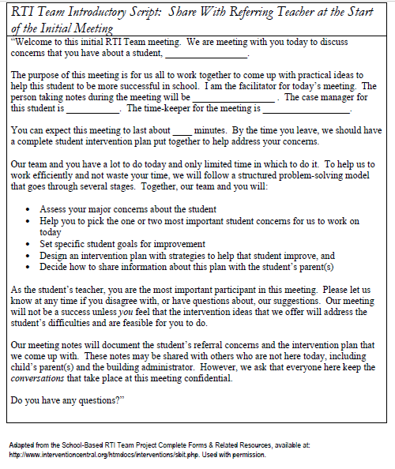

Resources
Resources should be located in a convenient location so that teachers can access them readily. The RtI chairperson would be the likely person to manage books, suggest websites, publications, games, and assorted activities. There are many websites available to assist with matching skill need to interventions. It is important to note that all interventions be aligned to the skill need. A website in not an intervention. The activities aligned to a skill can be used for the interventions. It will be the responsibility of the RtI team to provide interventions that will address student skill needs.
Valuable websites:
Center on Instruction: http://www.centeroninstruction.org/designing-and-delivering-intensive-interventions-a-teachers-toolkit.
Core Knowledge Assessment and Remediation Guide (K) https://www.engageny.org/resource/kindergarten-ela-skills-strand-assessment-and-remediation-guides
CKLA (Grade 1) https://www.engageny.org/resource/grade-1-skills-unit-1-assessment-and-remediation-guide
CKLA (Grade 2) https://www.engageny.org/resource/grade-2-ela-skills-strand-assessment-and-remediation-guides
Consortium on Reading Excellence (CORE) www.corelearn.com

- Resources for evidence-based reading interventions

Google Scholar--http://scholar.google.com
- Find relevant, research-based references for interventions you’re considering
- Type in key words to be directed to articles

Intervention Central http://www.interventioncentral.org/home
National Center on Student Progress Monitoring--http://www.studentprogress.org

Newsela – collection of news articles that you can adjust the Lexile. https://newsela.com/

The Florida Center for Reading Research http://www.fcrr.org/

The Savvy Teacher’s Guide: Reading Interventions that Work http://www.jimwrightonline.com/pdfdocs/brouge/rdngManual.PDF

Positive Behavioral Interventions and Supports PBIS.or

Reading Rockets –Reading resources http://www.readingrockets.org/reading_research_guides_resources

Read Works – Reading Comprehension Passages and Text Sets http://www.readworks.org/

Research Institute on Progress Monitoring--http://www.progressmonitoring.org

RtI Action Network http://www.RtInetwork.org/

What Works Clearinghouse http://ies.ed.gov/ncee/wwc/

Glossary of Terms
Aim Line
The path to move a student from his/her current, baseline level of performance, to the performance criterion, within a designated time period.

Behavior Intervention Plan

A behavior plan based on a Functional Behavior Assessment (FBA). It is developed and implemented by a collaborative team, which includes the student and parent. The plan includes positive behavior supports (PBS), identified skills for school success, and specific strategies for behavioral instruction.

Benchmark

Important student outcomes or goals for a grade within a specific domain (e.g., reading), that students should be achieving during the course of a school year (e.g., fall, winter, spring) in order to be on target for end‐of‐grade performance by the end of that school year benchmark assessments: assessments used to set benchmarks (e.g., according to local norms) and/or to determine whether students are achieving grade level standard.

Core Curriculum

A course of study deemed critical and usually made mandatory for all students of a school or school system. Core curricula are often instituted at the primary and secondary levels by school boards, Departments of Education, or other administrative agencies charged with overseeing education. Core curricula must be scientific and research-based.

Curriculum-Based Measurement

Curriculum-Based Measurement (CBM) is a family of brief, timed measures that assess basic academic skills. CBMs have been developed to assess phonemic awareness, oral reading fluency, number sense, math computation, spelling, written expression and other skills. Among advantages of using CBM for classroom assessment are that these measures are quick and efficient to administer; align with the curriculum of most schools; have good ‘technical adequacy’ as academic assessments; and use standard procedures to prepare materials, administer, and score (Hosp, Hosp & Howell 2007)

Cut point
Cutoff scores on common benchmark assessments; cut points specify the score at or below which students would be considered for intervention.

Data-Based/Data-Driven Decision Making

A process of collecting, analyzing, and summarizing information to answer a question and to guide development, implementation, and evaluation of an action. Data-based decision making is continuous and regular, and most importantly linked to educational/socially important questions.

Differentiated Instruction

Process of designing lesson plans that meet the needs of the range of learners; such planning includes learning objectives, grouping practices, teaching methods, varied assignments, and varied materials chosen based on student skill levels, interest levels, and learning preferences; differentiated instruction focuses on instructional strategies, instructional groupings, and an array of materials.

Evidence-Based Practice

Educational practices/instructional strategies supported by relevant scientific research studies.

Explicit Instruction

Systematic instructional approach that includes a set of delivery and design procedures derived from effective schools' research merged with behavior analysis; essential components of well-designed explicit instruction include a) visible delivery features of group instruction with a high level of teacher and student interactions and b) the less observable, instructional design principles and assumptions that make up the content and strategies to be taught.

Fidelity of Implementation & Instruction
Implementation of an intervention, program, or curriculum according to research findings and/or on developers’ specifications.
Five Critical Elements of Reading:
- Phonemic Awareness is the ability to hear and manipulate the sounds in spoken words and the understanding that spoken words and syllables are made up of speech sounds.
- Phonics addresses the relationships between letters and their related sounds, an understanding that these relationships are systematic and largely predictable, and use of these relationships to read and write words.
- Fluency is the ability to read connected text rapidly, smoothly, effortlessly, automatically, with prosody, and with little conscious attention to decoding (the ability to apply knowledge of letter sound relationships, including letter patterns, to decipher and pronounce written words), attention on the meaning and message of the text. Text is read with appropriate intonation and expression that sounds very much like conversational speech.
- Vocabulary development involves knowledge of word meanings, morphology, and word-learning strategies and usage.
- Comprehension is the process of constructing meaning from written text. It includes such skills as: activating prior knowledge, understanding what is read, sequencing, summarizing, making inferences, predicting, and making connections between new and unknown information.

Formative Assessment/Evaluation
Classroom/curriculum measures of student progress; monitors progress made toward achieving learning outcomes; informs instructional decision making.

Functional Assessment
Behaviors: Process to identify the problem, determine the function or purpose of the behavior, and develop interventions to teach acceptable alternatives to the behavior.
Academics: Process to identify the skill gap, determine strategies that have and have not been effective, and develop interventions to teach the necessary skill(s).
Intensive Intervention
Academic and/or behavioral interventions characterized by increased length, frequency, and duration of implementation for students who struggle significantly often associated with narrowest tier of an RtI model; also referred to as tertiary interventions.
Learning Disability
IDEA 2004 defines a Learning Disability/Specific Learning Disability in the following manner: The child does not achieve adequately for the child’s age or to meet State-approved grade-level standards in one or more of the following areas, when provided with learning experiences and instruction appropriate for the child’s age of State-approved grade-level standards.
- Oral expression
- Listening comprehension
- Written expression
- Basic reading skill
- Reading fluency skills
- Reading comprehension
- Mathematics calculation
- Mathematics problem solving
Modifications
Alterations that change, lower, or reduce learning expectations. Modifications can increase the gap between the achievement of students with disabilities and expectations for proficiency at a particular grade level. Consistent use of modifications can negatively impact grade level achievement outcomes.
Positive Behavior Support
A tiered intervention system based on school-wide practices that encourage and reward positive student and adult behavior.
Problem Solving Team
Group of education professionals coming together to consider student-specific data, brainstorm possible strategies/interventions, and develop a plan of action to address a student-specific need.

Professional Learning Community
Group of individuals who seek and participate in professional learning on an identified topic.
Progress Monitoring
Continuous measuring and comparing of student learning to determine progress toward targeted skills with the purpose of appropriately adjusting instruction. The assessment process entails the collection and analysis of student data to evaluate their academic performance on specific skills of general outcomes.
Rate of Progress
The student performance across time, determined by analyzing multiple points (minimum of three) of data that are graphed.
Research-based Instruction/Intervention
A research-based instructional practice or intervention is one found to be reliable, trustworthy, and valid based on intervention to suggest that when the program is used with a particular group of children, the children can be expected to make adequate gains in achievement. Ongoing documentation and analysis of student outcomes helps to define effective practice. In the absence of evidence, the instruction/intervention must be considered “best practice” based on available research and professional literature.

Response to Intervention (RtI)
Practice of providing high-quality instruction and interventions matched to student need, monitoring progress frequently to make changes in instruction or goals, and applying child response data to important educational decisions.

Scaffolding
An instructional technique in which the teacher breaks a complex task into smaller tasks, models the desired learning strategy or task, provides support as students learn to do the task, and then gradually shifts responsibility to the students. In this manner, a teacher enables students to accomplish as much of a task as possible without adult assistance.

Scientific, Research-Based instruction
Curriculum and educational interventions that have been proven to be effective for most students based on scientific study.

Scientifically-based Research
Education related research that meets the following criteria:
- Analyzes and presents the impact of effective teaching on achievement of students
- Includes study and control groups
- Applies a rigorous peer review process
- Includes replication studies to validate results

Specific, Measurable Outcome
The statement of a single, specific desired result from an intervention. To be measurable, the outcome should be expressed in observable and quantifiable terms (i.e., Johnny will demonstrate mastery of grade-level basic math calculation skills as measured by a score of 85% or better on the end of the unit test on numerical operations).

Strategic Interventions Specific to Need
Intervention chosen in relation to student data and from among those that have been documented through education research to be effective with like students under like circumstances.

Summative Assessment/Evaluation
Comprehensive in nature, provides accountability, and is used to check the level of learning at the end of a unit of study.
Tertiary Levels of Intervention
Interventions that relate directly to an area of need; are supplementary to and are different from primary and secondary interventions, are usually implemented individually or in very small group settings; may be individualized; are often connected to the narrowest tier of a tiered intervention model.
Tiered Instruction
An instructional delivery model which outlines intensity of instruction within a multi-tiered prevention/intervention system.
Tiered Model
Common model of three or more tiers that delineate levels of instructional interventions based on student skill need.
Trend line
Line on a graph that connects data points; compare against aim line to determine responsiveness to intervention.

Universal Design for Learning (UDL)
Process of designing instruction that is accessible by all students; UDL includes multiple means of representation, multiple means of expression, and multiple means of engagement; the focus in creation of UDL curricula is on technology and materials.
Universal Screening
A quick check of all students’ current levels of performance in a content or skill area administered three times per year. Universal screening is a school-wide measure used to determine which students fall below grade-level norms and, thus, may require intervention services.
Validity
The extent to which a screening tool accurately measures the underlying construct that it is intended to measure.

Appendix A
3 – Tier Model Reference
Table: Description of Critical Elements in a 3-Tier RtI Model
The following table outlines the essential features of a three-tier model of RtI including suggested ranges of frequency and duration of screening, interventions and progress monitoring. This is intended as guidance for districts as they determine the various components of their RtI model.
Elements | Tier 1 Core Curriculum and Instruction | Tier 2 Supplemental Instruction | Tier 3 Increased Levels of Supplemental Instruction
Size of instructional group | Whole class grouping | Small group instruction (3-5 students) | Individualized or small group instruction (1-2 students)
Mastery requirements of content | Relative to the cut points identified on criterion screening measures and continued growth as demonstrated by progress monitoring | Relative to the cut points identified on criterion screening measures and continued growth as demonstrated by progress monitoring | Relative to the student’s level of performance and continued growth as demonstrated by progress monitoring.
Frequency of progress monitoring | Screening measures three times per year | Varies, but no less than once every two weeks | Varies, but more continuous and no less than once a week
Frequency of intervention provided | Per school schedule | Varies, but no less than three times per week for a minimum of 20-30 minutes per session | Varies, but more frequently than Tier 2 for a minimum of 30 minutes per session
Duration of intervention | School year | 9-30 weeks | A minimum of 15-20 weeks

Adapted and reprinted with permission from Johnson, E., Mellard, D., Fuchs, D., McKnight, M. for NRCLD (2006, August) Responsiveness to Intervention (RtI): How to Do It
Newburgh Enlarged City School District
RtI - Teacher Referral Form
Please provide the information below so that we will be better prepared at the initial RtI Meeting to talk with you about the needs of your student.
Referring Teacher: ______________________________ Date: ___________
Student’s Name: ________________________________ Grade: __________
ID # ___________________________ Date of Birth: ___________________
Has the student been retained? No _______ Yes ______ Grade retained _______

General Information School __________________________
Dominant Language: _________________
Parent/Guardian: _________________________________________________
Address: _______________________________________________________
Phone: _________________________________________________________
Date (s) of parent/guardian contact: __________________________________
Name of person who contacted parent/guardian _________________________
Please check off all methods used to contact parent/guardian:
____Face –to- face ____ Phone call ____Note home with student
____Note mailed home
If you were unable to contact parent, how many attempts were made? _________
Has an administrator been notified? ______ (Name) ____________________
How is the student’s attendance? ______________________
State number of days absent: _________________________
Has the attendance officer been contacted (if applicable)? No / Yes ____
(dates) _____
List any current school or agency support services or programs in place for this student:
______________________________________________________________________

Please describe the specific academic concerns for this student. __________________________________________________________________________________________________________________________________________________________________________________________________________________________________________________________________________________________________________________________________________________________________________________________________________________________________________

Instructional Information
Consider any academic, social, emotional, or medical factors that seem to negatively affect the student’s progress. Please check all that apply. (For academic concerns, please provide data).
Academic | Behavioral | Social/Emotional | Occupational
Reading ____ | Attention ____ | Immaturity ____ | Fine Motor ____
Writing ____ | Motivation ____ | Home related issues ____ | Gross Motor ____
Mathematics ____ | Social Skills ____ | Self- Esteem | Organizational ____
Science ____ |  | Aggressive | Handwriting ____
Social Studies ____

What are several strengths, talents, or specific interests for this student?
- __________________________________________________________________________________
- __________________________________________________________________________________
- __________________________________________________________________________________

State any medical or health concerns for this student:
__________________________________________________________________

Please provide the following data:
Running Record Level _____ State Assessments: ELA _____ Math _____
DIBELS _____ (if applicable) SMI ______
SRI _____ Other _________________________________

Please describe the specific behavior concerns for this student.
__________________________________________________________________________________________________________________________________________________________________________________________________________________________________________________________________________________________________________________________________________________________________________________________________________________________________________

Intervention Record
Briefly describe the nature of the interventions you have provided: _____________________________________________________________________________________________________________________________________________________________________________________________________________________
*Please note a copy of the Tier 1 and/or Tier 2 intervention plan(s) must be included with this referral.
Newburgh Enlarged City School District
Health Form for RtI

Student _______________________________ DOB: _______________________
Grade: __________ Teacher: _________________________________
RtI Meeting Date and Time: ________________________ School ____________
Medical History (Including chronic health conditions, allergies, and significant health issues)
___________________________________________________________________________________________________________________________________________________________________________________________________________________________

Screenings
Type | Date | Results | Referral Date (s) | Findings (if any)
Vision
Hearing
Frequency of health office visits. Briefly describe the nature of visits.
__________________________________________________________________________________________
Describe any other significant observations/referrals:
___________________________________________________________________________________________________________________________________________________________________________________________________________________________

Signature of CPNP/SNT: __________________________________________________
S.M.A.R.T. Goals
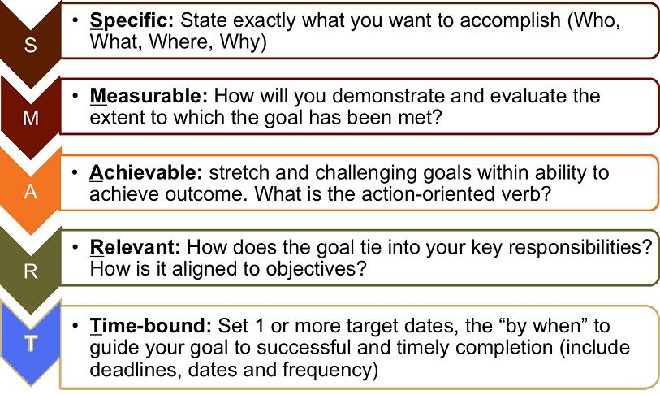

RtI Quick Reference
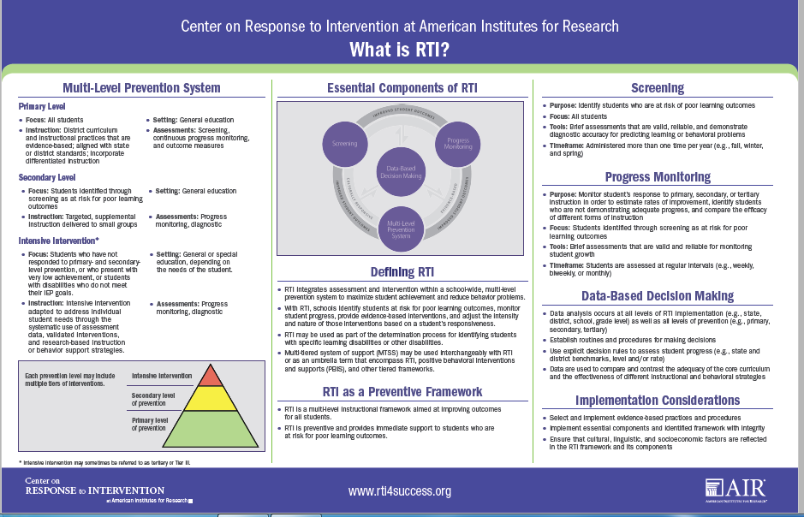
(Retrieved from http://www.rti4success.org/resource/essential-components-rti-closer-look-response-intervention)

