**2024-2025 Fostertown Dual Language 2nd Grade Supply List**

| **1 pair of wired headphones**  **(Please no rechargeable headphones)**  Image result for headphones images | **1 pair of pointed Fiskar Scissors**  Image result for fiskar pointed school scissors | **1 pack of small Elmer’s glue sticks** | **1 pack of low odor fine point dry erase markers (black only)**  Image result for dry erase markers |
| --- | --- | --- | --- |
| **1 Mead Primary Journal**  Image result for mead primary journal | **1 Marble Composition Notebook**Image result for marble composition notebook | **1-2 boxes Ticonderoga Pencils** | **2 boxes of Crayola Crayons**Image result for 24 crayola crayons |
| **1 box of Crayola Markers**  Image result for crayola markers | **1 box of Crayola colored pencils** | **4 folders**  **1 orange**  **1 green**  **1 red**  **1 blue**Image result for red plastic folder | **Highlighter Markers** |
|

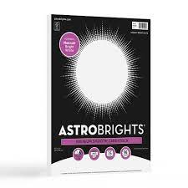

| **Boys**  **1 pack of white cardstock**    **1 box of gallon sized ziploc bags** |  | **2nd Grade Wishlist:**  **Options for Donation!**  **1 Box of Tissues**  **1 Roll of Paper Towels**  **1 Container of Disinfectant Wipes**  **1 Large bottle of Hand Sanitizer** |
| --- | --- | --- |
| **Girls**  **1 pack of colored cardstock**    **1 box of sandwich sized ziploc bags.** |