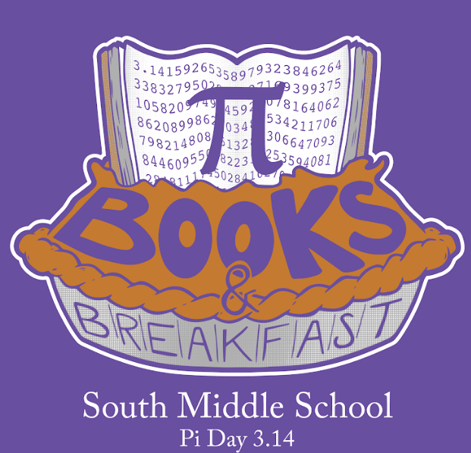
Saturday, March 14th @SMS!!
This year we are having our event on
Pi Day! To celebrate the math connection, we are also pre-selling pies!
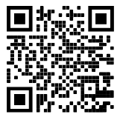

Buy a pie (until Feb 28) and/or Register (until March 13) to let us know when you are coming & how many are in your party! Fill out the form on the back of this sheet, QR code here or online at smsgoldbacks.com/breakfast
T-Shirts order forms available in the main office, until Feb 21.
Community Organizations
Face Painting
Are you SMARTER than YOUR 7th Grader!
Free Food!
Free Books!
Free Info Sessions!
ENL Parent Event!
Cyber Safety Workshops for parents!
Live Music by the Books & Breakfast Band
Special Preview of our Spring Musical: Beauty & the Beast

