John B. Murphy, Ph. D.
SEL Program: “ON THE ROAD TO SOCIAL AND EMOTIONAL LEARNING”

• Teacher will: Lead the students through the SEL video of the day.
• Students will: Watch Video and discuss/share-out based on the day's video experience…

What I shared with my students June 22, 2021:

The school year is about to end! Just the mere thought can send students into endless smiles, giddiness, and a state of sheer bliss. That doesn't even come close to what it can do for teachers!!! Oh yes, teachers are a dedicated lot who are bound to their career via a strange vocational yearning - but they also like summer, alone time, and a break from it all! This year especially demands Rest and Recuperation as there has never been a teaching year quite like it! Yet, for educators who are motivated by passion, excellence, dedication and love - the mind never stops. Planning always seems to continue. And, the needs of "their kids" are always close to heart. Today, we are going ON THE ROAD to meet one such teacher. I am sure that he's not perfect, no one is... However, he strives to "get it right," serve his students to the best of his ability, and when he least expected it, he rose to a special need and became more for one student than any "job" could ever expect. However, to any teacher On The Road with us - they get it; they understand! He did what he had to do. He acted out of love. Why? Because he's a teacher!

https://www.youtube.com/watch?v=OvDJmViRIdY&t=1s

What I posted for my students June 18, 2021:

Sunday is Fathers' Day. Next week, we'll spend some time ON THE ROAD with Steve Hartman and his dad. It will be a journey worth taking and it will continue our tribute to all of our fathers and those people who are "like fathers to us" in our life. But for today, we're going to go ON THE ROAD to meet a husband and father who is falling into the shadows of Alzheimer disease... No one wants to forget their life and all the details and memories that has made life worth living. Yet, you "play the cards you are dealt!" It's all part of life and ageing and passing away. But the mind and the heart seem to be uniquely connected and this husband and dad is about to prove that point for as he is losing everything that defines his life, his love is still alive! It anchors him and reminds him not only who he is, but who in this world he is living for...

https://www.youtube.com/watch?v=tmNNmuqCoo4

~~~~~~~~~~~~~~~~~~~~~~~~~~~~~~~~~~~~~~~~~~~~~~~~~~~~~~~~~~~~~~~~~~~~~~~~
What I posted for my students June 17, 2021:
There are "unsung heroes" who make life easier... We see them every day and we often take them for granted. The ladies in the cafeteria who greet us with smiles or ask how we are and seem to really care about the answer. The crossing guard to keeps us safe and gives us a wink when we look back over our shoulder. The custodian who always knows where everything is and drops everything to help us when we ask for something big or something small. The folks in the main office who know our names and know our parents and seem to know more than they pretend, but always listen to our stories with an open mind and offer suggestions to make things better. All these people are doing their jobs, but they are demonstrating incredible care for us as persons. Their jobs have become more than jobs because we are more than us "kids," clients, coworkers, etc. We are their "other family." I bet you know what I'm talking about! Let's go ON THE ROAD today and meet one of those special people who does more than drive a bus. He makes the world a better place for "his kids." They know he loves them. They see it; they feel it every day! Let's hop on board and be part of that love-in-action today!
https://www.youtube.com/watch?v=4024bmlMAfM&t=19s

What I posted for my students June 14, 2021:

We have 8 classes left. It's hard to believe that our year which in many ways seemed endless, is finally coming to an end! I have to admit that in spite of the pandemic and all the sadness and fear that hovered over us, this year will rank as one of my favorites! I have witnessed incredible acts of kindness this year. I have marveled at the bravery of healthcare workers and people who were deemed "essential." I have seen firsthand what charity-in-action looks like, and what compassion can do to move the spirit, heal the heart, calm the worried, and communicate love in countless ways. I have loved taking my classes ON THE ROAD and meeting individuals, families and communities that astound us into silence, smiles, or a tear that we try to hide... We have learned more Spanish than you realize and established a strong foundation for Spanish I to be built upon. We've grown up and are ready for whatever comes next... Yet, have we fully appreciated what kindness can do and are we ready to go ON THE ROAD ourselves and treat others as neighbors, brothers and sisters? Let's see what one community did very recently for two individuals who were known to some, but not to all. Yet, because there was a need, a community responded as a family - as one-unit intent on doing something wonderful for a couple's wonderful day which suddenly went up in smoke! Let's pay them a visit ON THE ROAD.

https://www.youtube.com/watch?v=ELNQRtPAYr8&t=5s

~~~~~~~~~~~~~~~~~~~~~~~~~~~~~~~~~~~~~~~~~~~~~~~~~~~~~~~~~~~~~~~~~~~~~~~~
What I shared with my students June 10, 2021:

We recently met Lauren Hill. You watched her play her first College basketball game. You got a sense that she is a special young woman. Today, we’ll go back in time and see what led up to that game. You’ll meet her parents and coach. You’ll get a sense of how many people were touched by her story and inspired by her who she was, how she lived, and the choices that she made. There are tears; there are smiles. And there is a prevailing sense that the spirit of this young athlete cannot be contained even in an arena built for 10,000!

https://www.youtube.com/watch?v=iw3Hi4L1nR8

~~~~~~~~~~~~~~~~~~~~~~~~~~~~~~~~~~~~~~~~~~~~~~~~~~~~~~~~~~~~~~~~~~~~~~~~
What I shared with my students June 8, 2021:

Who is it that inspires you? Who is it that you think of when you are discouraged, tired, beaten, or "down?" I think of Lauren Hill. We're going to meet her ON THE ROAD today. And, we're going to learn her story this week... It's a story worth knowing. She's a person worth meeting, remembering and honoring. She's 19. She'll always be 19. But her example shall be ageless and her courage is defined in character, strength, determination and sheer will. She's full of life; she is cursed with cancer. She is hope on a basketball court and an inspiration for the ages. She's the friend that we never met, the sister that we never had, and the person we are called to love in everyone we meet today.
https://www.youtube.com/watch?v=-bIe6y1y5XQ&t=7s

~~~~~~~~~~~~~~~~~~~~~~~~~~~~~~~~~~~~~~~~~~~~~~~~~~~~~~~~~~~~~~~~~~~~~~~

What I shared with my students June 2, 2021:

As you all know, TAPS across America had its 2nd national exposure on Monday, Memorial Day 2021. From the most talented to the most challenged, from the most seasoned to the greenest newbie, those 24 notes all sounded out patriotism, honor and respect to our nation and those who paid with their lives to keep us free, safe and diversely united in the quest for life, liberty and pursuit of happiness. Two of our Temple Hill Spanish 7 Scholars were a part of the music, memorial and memories... We thank them and we thank the youngest and the oldest, the most talented and the most enthusiastic! We thank those who paused and listened. Saluted. Beamed with pride. Fought back a tear... We crowned our good with Brother and Sisterhood on Monday. And we now go back ON THE ROAD to witness patriotism and honor, respect and decency played with heart and listened to with sincere appreciation.
https://www.youtube.com/watch?v=TxoDe_mSGGg

~~~~~~~~~~~~~~~~~~~~~~~~~~~~~~~~~~~~~~~~~~~~~~~~~~~~~~~~~~~~~~~~~~~~~~`
(2-3 day SEL Video)
Who was considered to be the GREATEST athlete of all time? In fact, he told us that he was! He had a talent, a spirit, an ego and "a mouth" that makes him very difficult to forget! Have you figured it out? It's Muhammad Ali! When he died on June 3, 2016, he left a legacy as complex and mighty as the man himself. He proved himself to be more than a boxer... He made decisions that impacted his life, challenged traditional thought, sparked debates in homes across America, challenged an unjust war, stirred the conscience of the civil rights movement, and challenged a sitting President of the United States. And when he died, America collectively "choked-up." His life experience was a journey that needs to be revisited by 7th grade this week. He knew what he wanted to be in life - the greatest boxer America had ever witnessed. But when did he receive the call to a different kind of Greatness that encompassed so much more? And, what lesson is there for us as we begin our adolescent journey? Let's go On Our Own Road and discover Muhammad Ali and in the process, see what we can discover in ourselves.
https://www.youtube.com/watch?v=7XB3sD9QJCI
~~~~~~~~~~~~~~~~~~~~~~~~~~~~~~~~~~~~~~~~~~~~~~~~~~~~~~~~~~~

What I posted for my Students May 25, 2021:

Yesterday we went ON THE ROAD to Tacoma, Washington and experienced Taps - that 24 note musical paradigm of solemnity, peace, sorrow, honor, respect and stillness. Today, we will go back ON THE ROAD and embrace the experience once again as we honor the men and women who selflessly offered their service and their lives to these United States. Perhaps with each musical note or trumpet played, a better sense of Memorial Day will take root within us. It is said; "All gave some, some gave all..." As we approach Memorial Day 2021, we salute those who met their end in places that are difficult to spell but hard to forget.

https://www.youtube.com/watch?v=83zvu1-b8jo
~~~~~~~~~~~~~~~~~~~~~~~~~~~~~~~~~~~~~~~~~~~~~~~~~~~~~~~~~~~~~

When I was growing up in the 1960's, I remember meeting men who were veterans of World War I. They were old already... Many had grown small in physical stature. However, when talk of their service arose - something eternally youthful about them seemed to spark from within and they somehow grew taller and stronger. And although very closed-mouthed about their service and always deferential to those whose lives were lost, I just had the sense that I was standing in the presence of greatness. I had that experience again this weekend when by accident, I met a 96-year-old volunteer at a local hospital. I loved the tone of her voice and knew she came from "somewhere else." She told me that place was London. I quickly did the math and asked if she was there during the Blitz. She was. And in fact, had been buried alive twice, once when her home was destroyed and once when taking refuge in the Underground (London's Subway.) It had been hit by Hitler's 3rd wave of rockets and became no longer safe. She married an American Sailor and moved to the USA! Now at 96, she wheels patients at the hospital. Today, we go On The CBS Road and meet a man of that era, the World War II generation. We learn of his duty, heroism, humility and on-going service. And although Memorial Day 2021 is over and the 24 note Music TAPS salute is a memory, the last surviving WWII Medal of Honor recipient keeps the Gold Star shinning.

https://www.cbsnews.com/news/medal-of-honor-marine-cpl-hershel-woody-williams/

~~~~~~~~~~~~~~~~~~~~~~~~~~~~~~~~~~~~~~~~~~~~~~~~~~~~~~~~~~~~~~~~~~~~~

What I posted for my students May 17, 2021:

May is here and that begins the "Season of Graduation Addresses!" I have to admit, I love a good graduation speech especially if it inspires, entertains, challenges and invites us to think! Today, we are going to listen to the first half of an address given in 2014. We'll listen to part II tomorrow... I believe that it's worth hearing...reflecting upon and perhaps, internalizing! What are you being invited to do? What's the message behind the words, humor and majesty of the moment? Listen! What 5 things are mentioned today as action steps? Are you up to the task? Did you make your bed this morning or are you a sugar cookie? https://www.youtube.com/watch?v=pxBQLFLei70&t=375s

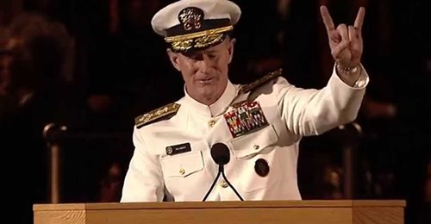

~~~~~~~~~~~~~~~~~~~~~~~~~~~~~~~~~~~~~~~~~~~~~~~~~~~~~~~~~~~~~~~~~~~~~~~~
This Sunday, May 9th is Mother's Day 2021. I hope you're planning what kind of card you're going to make your mom! Moms love home-made Mother's Day cards because they reflect who you are and all the love you hold in your heart... Today, we're going ON THE ROAD to meet a mom who won't be getting a card from her little girl this year. The gift of this child was not to last for a very long time. In fact, it only lasted 33 days. But the love of motherhood was deep, honest, real and true. It will last for the rest of this mom's life! Love's like that and I bet you already knew it! So, let's see that special kind of love in action. And let's think about this mom and any other mom who might not be opening up a Mother's Day card this year, but who once upon a time - opened themselves up to unselfish love, which changed the lives of all those around them.
https://www.youtube.com/watch?v=2z75rQV00wY&t=4s

What I posted for my students May 7, 2021:

So much of what we encounter ON THE ROAD can be happy, yet sad at the same time. I suppose older folks would call that MELANCHOLY. The stories move us. They make us smile. And sometimes, a tear can well up “in spite of ourselves!” Yes, it's quite a life that we live when we're ON THE ROAD... Today as we ready ourselves for Mother's Day, we are going to meet a mother and daughter who are looking at a future that would scare anyone and make many of us sad, tearful, angry or bitter. Yet for these two remarkable ladies, they have found JOY. And in their JOY, they are gifting others with their spirit. Let's go meet them!
https://www.youtube.com/watch?v=kvFDOl9UEu4

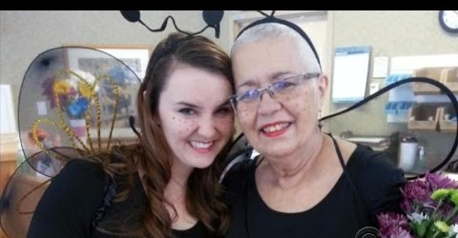

~~~~~~~~~~~~~~~~~~~~~~~~~~~~~~~~~~~~~~~~~~~~~~~~~~~~~~~~~~~~~~~

What I posted for my students May 4, 2021:

You never know what someone else is thinking or going through... You never know what love and loss can do to the heart and how it can impact a life! And when it suddenly impacts YOUR life as an unsuspecting bystander, you need to brace yourself for emotions and thoughts that "come out of nowhere..." Today we are going ON THE ROAD to visit a little boy who never knew the person he lost, yet misses him every day. And in his grief, he pays it forward in an act of kindness that touches the heart, inspires the masses, and makes his dad proud!
https://www.youtube.com/watch?v=9FCxuVSkT7k

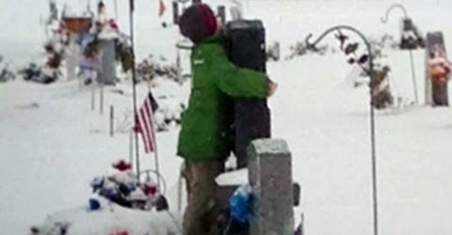

~~~~~~~~~~~~~~~~~~~~~~~~~~~~~~~~~~~~~~~~~~~~~~~~~~~~~~~~~~~~~~~~~~~

What I posted for my students April 30, 2021:

We all dream of being the "best" at something; don't we? But what happens when life throws us a curve ball and things just don't go our way? That's for all of us to figure out someday, but perhaps by going ON THE ROAD today we can gain some perspective and not strike out before the game of life is over! https://www.youtube.com/watch?v=BQ4v8NpY78E&list=PLotzEBRQdc0eX6sErNJED9JuHzJ1vcIu_

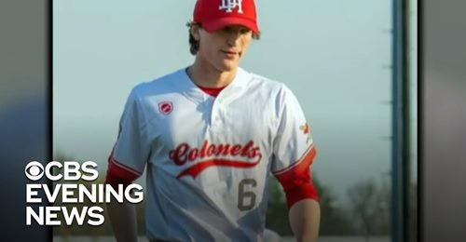
What I posted for my students April 29, 2021:

What I shared with my students April 29, 2021:
Did you watch this SEL video yesterday during Asynchronous Wednesday? Of all the A/Wednesdays that we have had, this was the only one where I assigned a SEL video! Did you think it was an important story? Did it surprise you in any way? Can you tell us about both characters in the story? Might you be able to relate to one or both? Let's go back ON THE ROAD and revisit this campaign. In the end, perhaps we'll be able to vote for the very best of humankind and end-up all "winners!"
https://www.youtube.com/watch?v=zJ6Wwt8Qlio

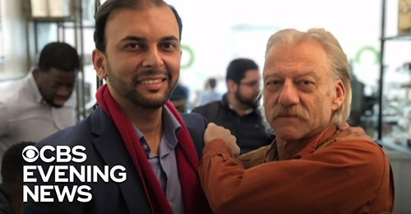

~~~~~~~~~~~~~~~~~~~~~~~~~~~~~~~~~~~~~~~~~~~~~~~~~~~~~~~~~~~~~~~~~~~~~~~

What I posted for my students April 27, 2021:

Sometimes friendship comes about from strange encounters and a history of interactions. The problem is that not all interactions are pleasant, and not all encounters are happy ones! Let's go ON THE ROAD today and meet two very unlikely friends, a cop and a criminal. They went from being bitter enemies to real pals! It was a long journey, but it was one worth taking... Let's join them for part of their story. And just maybe we can honor them by allowing their example to influence us as we continue On the Road of Life!
https://www.youtube.com/watch?v=_AFEmZ62lVw

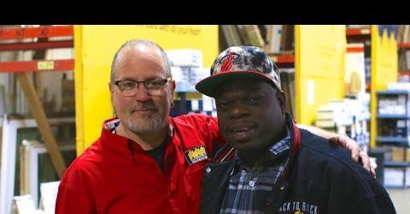

~~~~~~~~~~~~~~~~~~~~~~~~~~~~~~~~~~~~~~~~~~~~~~~~~~~~~~~~~~~~~~~~~~~~~

What I posted for my students April 26, 2021:

There are lots of people who are sad this year because they are moving forward without loved ones whom they've lost along the way of the pandemic. It's not easy. In fact, it's really hard! It's lonely, foreign and cold... They miss the familiarity of smiles, being tucked in at night, getting a hug and a giggle and squeeze. To lose that, just isn't easy. Today, we're going ON THE ROAD to meet someone who knows what it's like to lose it all. Yet in his quest for smiles, you just can't help but sense that in giving he will receive!
https://www.youtube.com/watch?v=vWVF1LSrYg0

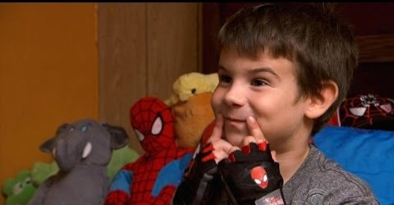

~~~~~~~~~~~~~~~~~~~~~~~~~~~~~~~~~~~~~~~~~~~~~~~~~~~~~~~~~~~~~~~~~~~~~~~~

What I posted for my students April 22, 2021:

We've talked a lot about our country and the world this week. And, we braced ourselves for the verdict that would be rendered in Minneapolis. Well, the verdict is in and marches and cheers and anger and news reports and talking-heads have all had their moment. It all servers a purpose… But in the quiet moments that we have spent ON THE ROAD, I wander back to two little girls who taught us all the true meaning of love and friendship. It's not a color-coated tale of fake race relations, but the story of how humanity is supposed to be. How our country is called to be. And how in our hearts, we know it ought to be...
https://www.youtube.com/watch?v=-x90tR8-g5o

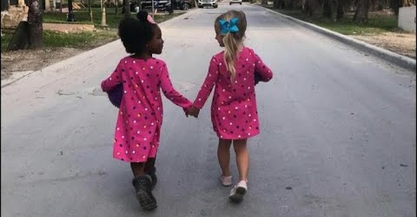

~~~~~~~~~~~~~~~~~~~~~~~~~~~~~~~~~~~~~~~~~~~~~~~~~~~~~~~~~~~~~~~~~~~~~

What I posted for my students April 20, 2021:

Do you want to change the world? Do you want to make it a better place? That's an awfully big job and responsibility! Just how do you go about such a daunting task? Perhaps you take the example of three young men who used kindness and goodness and love to begin the process... Let's go ON THE ROAD to a Barbecue Restaurant "down south," and watch as life and society and humankind all intersect in a booth, over a meal and conversation and laughter. And let's see if we'll ever be the same again as differences melt away and joy unites and becomes a common bond. You know, this could be tough week... We all await a verdict in Minneapolis. And in a way, we're all on trial. How will we be judged when we react to whatever the verdict will be? How are we supposed to move on, heal, learn and prevent such atrocities from happening again? Perhaps the example of four people in a "booth in a restaurant down south," will be our guide and example as we all wearily continue on our own road.
https://www.youtube.com/watch?v=xyhQyi_KrWE

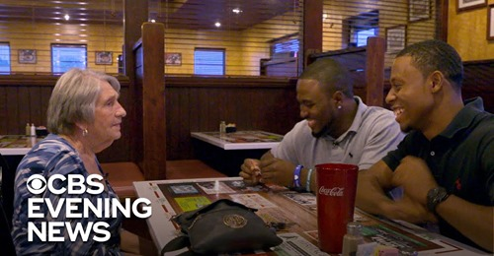

~~~~~~~~~~~~~~~~~~~~~~~~~~~~~~~~~~~~~~~~~~~~~~~~~~~~~~~~~~~~~~~~~~

What I posted for my students April 19, 2021:

Do you watch the news at night after dinner? Do you stream the headlines as you log onto your favorite website? Do you listen to the World News Roundup as your day is beginning? Do you read the front of the paper before you check out the "back" and your favorite team's scores? If you do any of these things or if you just listen to the radio and pay attention to the news-reports in between your Music, you may be aware that April has already been a difficult, challenging and sad month... We have countless unaccompanied minors who are scared and alone at our Texas - Mexico border. We have had a number of Police shootings and citizen deaths, and the Covid numbers are once again increasing. It's as if our country and the world are so angry that we can't get out of each other's way, respect our common humanity, and heal instead of hurt, love instead of hate... If only we could turn to someone who could help us to make sense of all of this, or at least help us cope and get back on track! Let's go ON THE ROAD and see if we can find a voice from our past that can help us to find our focus and be better neighbors to one another.
https://www.youtube.com/watch?v=a5IHO5cxH0A

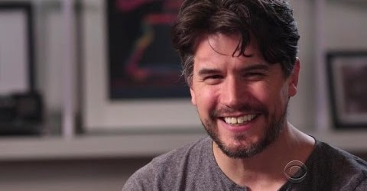

~~~~~~~~~~~~~~~~~~~~~~~~~~~~~~~~~~~~~~~~~~~~~~~~~~~~~~~~~~~~~~~~~~~~~~~

What I posted for my students April 15, 2021:

Lately, we've gone ON THE ROAD and been part of stories that have touched us in profound ways. One journey dealt with loss, and another dealt with a special love and support from a son who will soon lose his mother. After one of these stories, a student quipped: "This sort of just make you think..." Hopefully, today's will also make you think! Let's go back ON THE ROAD and journey down a path that we'll all have to travel someday. Perhaps along the way, we'll think of what we have or what we've already lost. And if we were to write a letter, a note, or a passage in a journal - what might it say?
https://www.youtube.com/watch?v=8hU43WU7LC0&t=6s

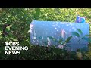

~~~~~~~~~~~~~~~~~~~~~~~~~~~~~~~~~~~~~~~~~~~~~~~~~~~~~~~~~~~~~~~~~~~~~

What I posted for my students April 12, 2021:

There's so much ugly in the world. We see it every night on the evening news. We hear it every day on the radio. And, it never stops on the internet... However, every day in class, we go ON THE ROAD and experience the very best of humankind doing things that give us pause, make us think, sparks a smile or invites a tear. Our stories are a reality that is laced with love. Today is no different. We will meet a son who loves his mom and a mom who is losing her battle with cancer. It won't be tomorrow, but it will happen. So how does a devoted son make her dream trip a reality? He fries up a recipe of goodness that nourishes the body and inspires a multitude. And you can guess what happens! Goodness becomes contagious and a dream becomes a reality.
https://www.youtube.com/watch?v=J9qX4Qm3djg
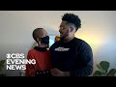

~~~~~~~~~~~~~~~~~~~~~~~~~~~~~~~~~~~~~~~~~~~~~~~~~~~~~~~~~~~~~~~~~~~~~~~

What I posted for my students April 10, 2021:

No one knows what life has in store for them. We're healthy one day and sick the next. We don't have a really close friend one day and then out of nowhere, a friend comes into our life! Our sickness turns to health, but it doesn't for our friend... That what happened to a pair of high school guys who found friendship in a cancer diagnosis, and then found that life isn't fair even if you get better - but your friend doesn't! Let's go ON THE ROAD today and meet a kid who lives on in health and in honor of his friend who lost his battle. Perhaps we'll discover that friendship, faith and basketball all have something that bonds them together.
https://www.youtube.com/watch?v=1cZb3bpfMP4
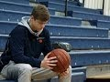

~~~~~~~~~~~~~~~~~~~~~~~~~~~~~~~~~~~~~~~~~~~~~~~~~~~~~~~~~~~~~~~~~~
What I posted for my students April 9, 2021:

Sometimes you just need a cup of coffee! I don't know why... Maybe it's the caffeine. Maybe it's a habit. Perhaps it's a social thing. It just seems to allow you to get a grip on your day and gives you a sip of confidence. That couldn't be more important than it is for those whom we'll meet ON THE ROAD today. They are experiencing a NEW normal and it isn't nearly as good as the OLD normal! However, someone provides them a service that gives them a jolt of normalcy and "the familiar" that they need in order to go on. It may just be a cup of coffee to some, but those whose lives are in a tenuous state, it gives them a sense of hope that they still are who they once were... And who knows, perhaps the warmth of that coffee and the love that delivers it - is just what the doctor ordered!
https://www.youtube.com/watch?v=eUihVjDI3Tg

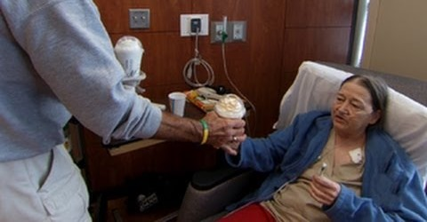

~~~~~~~~~~~~~~~~~~~~~~~~~~~~~~~~~~~~~~~~~~~~~~~~~~~~~~~~~~~~~~~~~~~~

What I posted for my students April 6, 2021:

Some people don't have it very easy in life. For some, life just isn't fair. We've seen that time after time ON THE ROAD this year. However, every once in awhile, life interrupts with a surprise that astounds with kindness, joy, new hope and love! That usually happens when someone steps out of their comfort zone to do the right thing, respond to some invitation to intervene in a special way, or be the person who they are "being called to be!" Let's go back ON THE ROAD and meet three guys who will encounter life and love on the mean streets of Pittsburgh and in a grimy boxing ring, and end up as an unexpected family...
https://www.youtube.com/watch?v=SxFujtETF8U

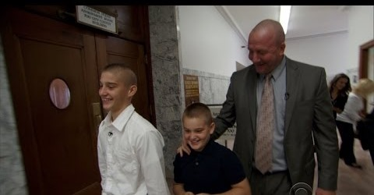

Some stories have a happy ending. And then again, some stories even get better! Let's go back ON THE ROAD and check on our former army-man turner police detective turned adoptive father of two boys. Could life possibly get any better OR more different for this confirmed bachelor?
https://www.youtube.com/watch?v=obXeG-xl6Y8&t=145s

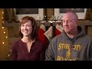

~~~~~~~~~~~~~~~~~~~~~~~~~~~~~~~~~~~~~~~~~~~~~~~~~~~~~~~~~~~~~~~~~~~
What I posted for my students April 5, 2021:

The internet is a dangerous place. We're not naive; we know that. Lots of people cannot be trusted. So, we keep our guard up and maneuver with great care, lest we be duped, taken advantage of, hurt, robed, or even worse... However. aren't we ever allowed to trust? Isn't it possible that there are people "out there" who are honest, who are telling the truth, and who are really in need? Let's go ON THE ROAD with someone who put that notion to the test and found more than he expected in his fellowman and in himself.
https://www.youtube.com/watch?v=-OH99CFzhFM

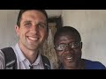
~~~~~~~~~~~~~~~~~~~~~~~~~~~~~~~~~~~~~~~~~~~~~~~~~~~~~~~~~~~~~~~~~~~~~~~

What I posted for my students March 23, 2021:

Yesterday, we met a girl who reminded us that anyone can make a difference if you just make the effort! Today, we continue in that spirit. Why? Because imagine if we truly believed that sentiment how much we'd accomplish right now! And imagine how much we could accomplish in a lifetime of not accepting the norm, but making the possible a reality! Let's go ON THE ROAD and soldier on...
https://www.youtube.com/watch?v=GVgwJNT2hSs

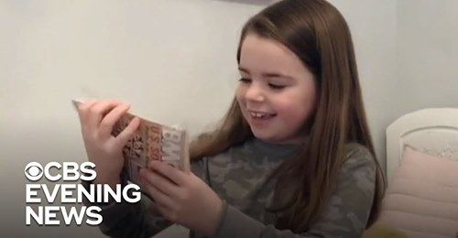

~~~~~~~~~~~~~~~~~~~~~~~~~~~~~~~~~~~~~~~~~~~~~~~~~~~~~~~~~~~~~~~~~~~~

What I posted for my students March 19, 2021:

Don't you hate "know-it-alls?" Is it because THEY know it all and WE don't? Could be, but they do serve a purpose... They help us to aspire to get things right. I am not an English teacher, but I love learning about grammar and how to improve my writing skills. As they say, "I'm no Spring Chicken," but learning isn't just for the young. It's a life-long proposition! So check my spelling and punctuation, syntax and dangling modifiers. And if you're as unsure as I can sometimes be, let's GO ON THE ROAD together and ask the know-it-all expert!
https://www.youtube.com/watch?v=_blcBKdJq_k

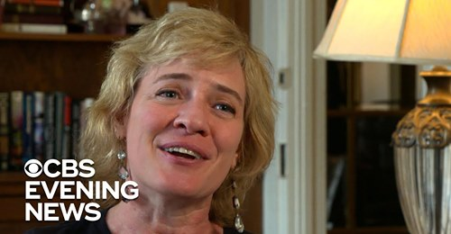

~~~~~~~~~~~~~~~~~~~~~~~~~~~~~~~~~~~~~~~~~~~~~~~~~~~~~~~~~~~~~~~~~~~~~~

What I posted for my students March 18, 2021:

The world is a busy, loud and crowded place. So how it is possible that anyone can feel so alone that tears flow at the thought of another Holiday without a family? It's not December now as when this video took place! However, emptiness and the hunger for love is not exclusive to one month of the year... Let's go ON THE ROAD and meet a young woman who decided that she needed to do something about her aloneness. And in her action, she discovered that she was not so alone!
https://www.youtube.com/watch?v=0SdttFKfN38
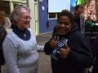

~~~~~~~~~~~~~~~~~~~~~~~~~~~~~~~~~~~~~~~~~~~~~~~~~~~~~~~~~~~~~~~~~~~~~~~

What I posted for my Students March 13, 2011:
Reminder: March is The Month of Women.

Men think that they are strong, and many are… However, this morning we are going to encounter a certain type of strength that is unique and awe-inspiring. It is found in a woman, a mom who suffered a terrible loss and found the strength to not only forgive, but to embrace the person who caused the pain. And then together, forge a new way forward! Let's go ON THE ROAD and meet another unique and strong woman.
https://www.youtube.com/watch?v=a7WMx7Vi8VM

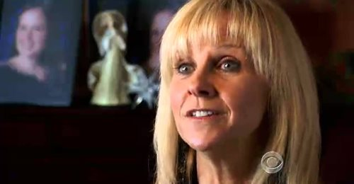

~~~~~~~~~~~~~~~~~~~~~~~~~~~~~~~~~~~~~~~~~~~~~~~~~~~~~~~~~~~~~~~~~~~~~~~~

What I posted for my Students March 12, 2011:

If you received a letter from a stranger asking you to be his/her friend, how would you respond? If you looked at that note and imagined how much loneliness it must have taken for that person to write such a request, would you RSVP with friendship? Let's go ON THE ROAD and meet two women at two different stages of life who were brave in different ways and found friendship not in a letter, but in their hearts.

https://www.youtube.com/watch?v=uv6-z7JITlg&t=8s
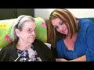
~~~~~~~~~~~~~~~~~~~~~~~~~~~~~~~~~~~~~~~~~~~~~~~~~~~~~~~~~~~~~~~~~~~~~~~~

What I posted for my Students March 11, 2011:
Reminder: March is The Month of Women.

We can take so many people in life for granted. They are always there. They do their jobs, but they can sort of be invisible...However, some of them do the ordinary in an extraordinary way. We've met many of them in this month dedicated to women! And it's a funny thing, but love seems to motivate a great many of them! In that same spirit, let's climb aboard a school bus today and meet another special lady who touches hearts and made a dream come true.
https://www.youtube.com/watch?v=LCW-FkiUC5U

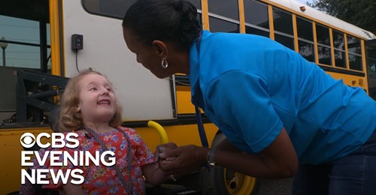

~~~~~~~~~~~~~~~~~~~~~~~~~~~~~~~~~~~~~~~~~~~~~~~~~~~~~~~~~~~~~~~~~~~~~~~

What I posted for my students March 8, 2021:
Reminder: March is The Month of Women.

Some people in this world are hungry for attention, importance, recognition, etc. And some people are just plain hungry! Let's go ON THE ROAD and meet someone who gives attention, makes everyone important, and recognizes everybody as a "brother and sister." And when you finish watching, consider if she isn't someone who deserves a little of her own recognition during this month dedicated to Women!
https://www.youtube.com/watch?v=QNzmhTaiH5E&t=4s

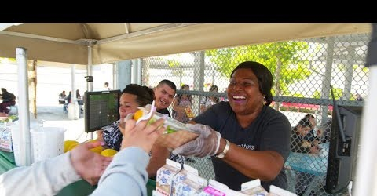

~~~~~~~~~~~~~~~~~~~~~~~~~~~~~~~~~~~~~~~~~~~~~~~~~~~~~~~~~~~~~~~~~

What I posted for my students March 2, 2021:

Do you remember yesterday's SEL video? What about the ones we viewed and discussed last week? Do you remember who you spoke with during lunch yesterday or hung out with on Saturday? What would it be like to remember none of it? What would it be like to have a "Groundhog Day experience" every day? Would it be awful or joyful? Would it make you lonely or look forward to filling in the silence with new noises and faces and memories - even if it meant that they too, would quickly fade away? Let's go ON THE ROAD and find out for ourselves in the person of "Mr. Gene."
https://www.youtube.com/watch?v=rDwdWaKSDuQ

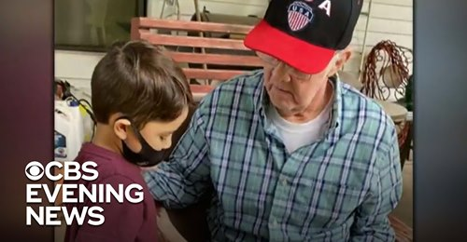

~~~~~~~~~~~~~~~~~~~~~~~~~~~~~~~~~~~~~~~~~~~~~~~~~~~~~~~~~~~~~~~~~~~~~~~

What I posted for my students Tuesday, February 23, 2021:
*SEL: February - THEME…. “E Pluribus Unum”

46 years is a long time to be in jail serving a sentence for a crime that you didn't commit. To put time into perspective, the man we are about to meet ON THE ROAD, went to jail when I (your teacher) was in 7th grade! Now he's a free man. But what does society owe to this gentleman for the crime we have done to him? And do we deserve to be a part of the richness of his joy, the color of his art, or the magical wonder of his soul? Anyone of us could suffer this man's fate... And in that awful reality, what is it that we can learn from the jailed artist who is now free?
https://www.youtube.com/watch?v=izD3oTsig-k&t=2s

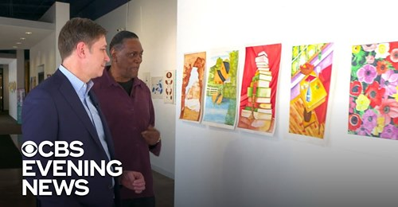

What I posted for my students Monday, February 22, 2021:
SEL: February - THEME…. “E Pluribus Unum”

A week ago we experienced OUTRAGEOUS LOVE! We saw it in the nurse who did more than her job required of her and as a result, an expectant mother and an unborn child are now healthy, together and blessed with a friend for life. Then we saw it in a man who was framed by a dishonest police officer. That man did time unjustly and then forgave the disgraced cop completely. Again, we talked about Outrageous Love in action! Today, let’s go ON THE ROAD and visit a community that takes Love Thy Neighbor seriously. Let’s consider how “Out Of Many – One,” is once again evident and how Love can be both a Service and a Process.
https://www.youtube.com/watch?v=nCKanFvkITk

What I posted for my students on Friday, February 19, 2021:
SEL: February THEME…. “E Pluribus Unum”

Yesterday we went On the Road an encountered a nurse who used Outrageous Love to save the life of her patient and the unborn child that she was carrying. The nurse and patient had little in common. They came from different walks of life, different socioeconomic backgrounds, different experiences... Yet, the nurse went beyond the scope of her job and in so doing defined her humanity, goodness and personhood. She used Outrageous love and it saved lives! Today is different. Today, we deal with the three things that we were charged to consider last night: Revenge - Forgiveness - Outrageous Love. It's a different kind of a story, but it reflects the topics that you have mentioned this month. Let's go back ON THE ROAD and be part of another journey.
https://www.youtube.com/watch?v=2ScONnplBsU

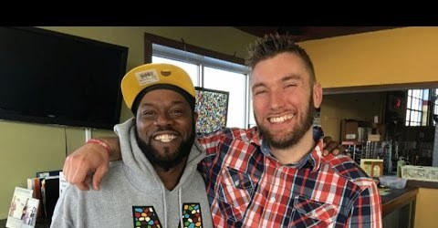

~~~~~~~~~~~~~~~~~~~~~~~~~~~~~~~~~~~~~~~~~~~~~~~~~~~~~~~~~~~~~~~~~~~

~~~~~~~~~~~~~~~~~~~~~~~~~~~~~~~~~~~~~~~~~~~~~~~~~~~~~~~~~~~~~~~~~~~~~~~~~~~

What I posted for my students on Friday, January 29, 2021:

Our month of “New Beginnings” draws to a close today and with it, our visits to Dan and Nora… During the waning days of a tumultuous month, it was good to be a part of the beginning, middle and now the end of a relationship which embodied the very best of humanity in action! As we discussed, there’s a lot of Dan and Nora in all of us. Sometimes we’re the ones waiting to be invited into friendship, and other times we’re the ones who are doing the inviting. Let’s go ON THE ROAD and end our month.
https://www.youtube.com/watch?v=SxCclaeQQ6E&t=1s

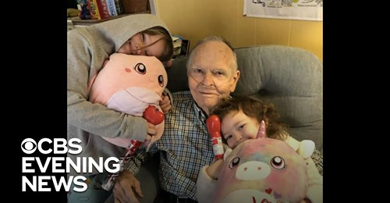

What I posted for my students today, Thursday, January. 28, 2021:
On Tuesday, we went ON THE ROAD and met an Odd Couple, Nora and Dan. You remember them... He is very old. She is very young. He seemed very sad and looked very grouchy. Then in the grocery store this very perky girl wanted a hug from him - a total stranger! As a matter of fact, she reached out from within the shopping cart where she sat and seemed to change his day and maybe even his life! What we didn't know at the time and won't know until we go back ON THE ROAD, is if this sudden and unlikely friendship endured. What do you think? Did the friendship make it, or did it wilt like the old lettuce in the veggie aisle? https://www.youtube.com/watch?v=ZYx7wY3jo80

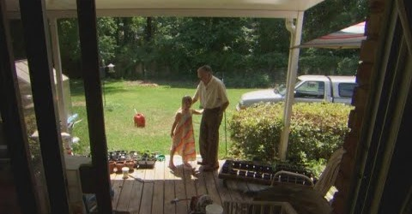

~~~~~~~~~~~~~~~~~~~~~~~~~~~~~~~~~~~~~~~~~~~~~~~~~~~~~~~~~~~~~~~~~~~~~~~~~

What I posted for my Students on Tuesday, January 26, 2012:
As we draw closer to the end of this month of “New Beginnings,” I’d like to go ON THE ROAD and introduce you to an Odd Couple who you might not at first glance think have very much in common. However one of the persons in what grew to be a special relationship, reached out to the other and sparked a friendship that saved his life, reminded him how to smile, and helped him spend his time with happy thoughts and joyful moments… https://www.youtube.com/watch?v=2d2vZV87YJM

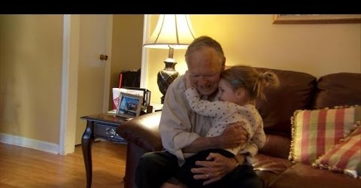

~~~~~~~~~~~~~~~~~~~~~~~~~~~~~~~~~~~~~~~~~~~~~~~~~~~~~~~~~~~~~~~~~~~~~~~
What I posted for my students January 25, 2021:
If you look at the news on TV, you might think that Democrats and Republicans can only “hate and distrust” each other. I’m sure that some do, but most don’t! As a matter of fact, two very different people from different parties and backgrounds have found common ground, good natured fun, and a special friendship – right in front of the American population. And in so doing have modeled for all what respecting opposite experiences and opinions, political perspectives and approaches ought to look like. And, we thank them for it… https://www.youtube.com/watch?v=-QBR5pSsdFQ

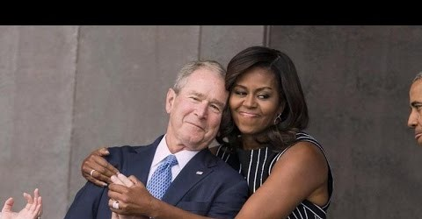

~~~~~~~~~~~~~~~~~~~~~~~~~~~~~~~~~~~~~~~~~~~~~~~~~~~~~~~~~~~~~~~~~~~~~~~~~~~
What I shared with my students January 11, 2021:
Our January THEME of New Beginnings continues....
We will soon have a new President, a new administration, a New Beginning. This process happens every four years; however, sometimes it happens sooner. One President died shortly after taking office, four Presidents were assassinated while in office, and one President resigned. This prompted their Vice Presidents to assume the Presidency. Those were moments of national tragedy, shock and sadness. And the voice of the New President helped calm the masses, heal the brokenhearted, and set the country on a new and steady path of continuance, possibility, hope and resolve. Today we await a new administration in the shadow of a nation’s capital wounded by anger, disillusionment, lawlessness and the loss of life. What will a New President say to heal what has been hurt, fix what has been broken, and fill a void which has been created? What would you want to hear? What would you say? In 1974, those must have been the same questions asked by Gerald R. Ford as he rose to the Presidency following the resignation of Richard M. Nixon. Let's go back in time and perhaps find our new beginning... https://www.youtube.com/watch?v=LySpUpI9k1s

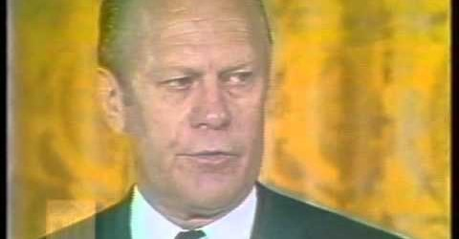

~~~~~~~~~~~~~~~~~~~~~~~~~~~~~~~~~~~~~~~~~~~~~~~~~~~~~~~~~~~~~~~~~~~~~~~~~

What I shared with my students January 19, 2021:
As I write this, Monday, January 18, 2021 is slowly coming to a close. It was Martin Luther King Day – a day of service, remembering and keeping a legacy alive in a DREAM that is still to be fully realized… A new week awaits with in-person classes, the departure of one President and the inauguration of a new President, the cancelation of one administration’s edicts and the forging of a new way and vision of new leadership. And more people will be tested, vaccinated, and diagnosed. And the news will keep showing January 6th imagines of the Capitol and new video of National Guard Troops in DC on-alert. And they’ll delve into what divides us instead of what unites us. So in opposition to that now daily trod, let’s go On The Road and put it all into perspective as we meet humanity in the flesh, where color doesn’t matter - but life, love and the makings of friendship define the very best of our American character. https://youtu.be/2ScONnplBsU?t=9

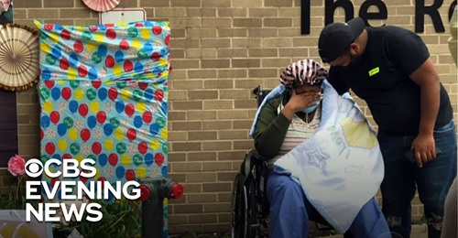

~~~~~~~~~~~~~~~~~~~~~~~~~~~~~~~~~~~~~~~~~~~~~~~~~~~~~~~~~~~~~~~~~~~~~~~~~

~~~~~~~~~~~~~~~~~~~~~~~~~~~~~~~~~~~~~~~~~~~~~~~~~~~~~~~~~~~~~~~~~~~~~~~~~~

~~~~~~~~~~~~~~~~~~~~~~~~~~~~~~~~~~~~~~~~~~~~~~~~~~~~~~~~~~~~~~~~~~~~~~~~~~~

What I posted for my students January 4, 2021:
SEL, January THEME: New Beginnings
In 2021, will you "finally" embrace the notion that YOU are learning to speak, comprehend, understand, write, and think in Spanish?! Will you be open to the concept that this is doable because irrespective of the roadblocks that we place before of our own learning, it's is happening in spite of ourselves and our own personal efforts of sabotage! And might we consider that Spanish is a "tad bit" easier to learn than English... Yes, I know that you think it's easy to learn English just because you speak English. However, let's visit some familiar faces who might think to the contrary!!! https://www.youtube.com/watch?v=uZV40f0cXF4

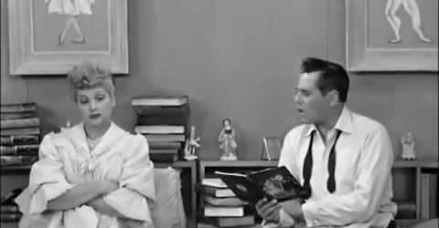

~~~~~~~~~~~~~~~~~~~~~~~~~~~~~~~~~~~~~~~~~~~~~~~~~~~~~~~~~~~~~~~~~~~~~~~~
What I posted for my students Friday, December 18, 2020:
SEL: December THEME: HOPE Our THEME of HOPE continues.
We have been watching our favorite “Secret Santa” at his work over the past decade or so... Now, this Santa has moved his special magic into our pandemic-filled Holiday Season and with it his gifts of joy, gratitude, recognition and yes – HOPE. From our computer screens, let's journey with him as he sparks joyful tears, a sense of better times to come, and a new meaning of Peace on Earth – Good Will Toward All...
https://youtu.be/55tZ1bXSeq0?t=9

~~~~~~~~~~~~~~~~~~~~~~~~~~~~~~~~~~~~~~~~~~~~~~~~~~~~~~~~~~~~~~~~~~~~~~

What I posted for my students Monday, December 14, 2020
Our THEME of HOPE continues.
We woke up this morning to news that Google had a Glitch! Something went wrong and the world got disconnected. Or, did it? Your parents still told you what was going on, brothers and sisters still did what brothers and sisters always do...fight for more sleep time, covers, the sugar left at the bottom of the FrootLoops Box, you know – you communicated in your own particular way. Grandparents read the newspaper and grunted comments about whatever is happening in the world. The dog let you know that he needed to be walked. And, you had to answer the phone and hear the words that Google was once again “back up and running.” So what really changed in your world? Probably not much; however, imagine the impact one person can have upon your world when you don't know how to pay your bills or buy what's needed at home, or make the Holidays happen for your kids? Let's go ON THE ROAD again and meet our favorite secret Santa and see him enlist a special band of ELVES to help impact lives and make a world of difference in the world of those who need it the most!
https://www.youtube.com/watch?v=Mjo2EJfRp1M

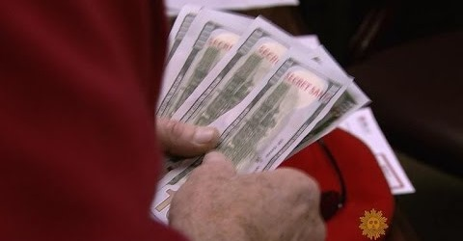

~~~~~~~~~~~~~~~~~~~~~~~~~~~~~~~~~~~~~~~~~~~~~~~~~~~~~~~~~~~~~~~~~~~~~~~~~

What I posted for my students December 10, 2020:
Our December THEME of HOPE continues.
Earlier this week, an anniversary happened that many of you may not have noticed. It was the 79th Anniversary of the Japanese attack on Pearl Harbor. In the harsh reality of pandemic numbers on the rise and our lifestyle once again being impacted in a "New Normal" kind of a way, that anniversary seems to have quietly come and gone! But we can't let it go before making note of how it changed the lives of millions of Americans and the world. Lives were lost. Youth was cut short. Peace was ended. Hope sank. Yet morning followed on December 8th, and with it a resolve to do what was necessary to overcome tragedy, conquer evil and remember what occurred so we would never let it happen again. Are there lessons in Pearl Harbor that we can apply to our current situation? With each tragic life lost, can we find the resolve to conquer even when the odds are against us? And in the legacy of America's Greatest Generation, can we find the HOPE to be America's next greatest generation?
https://www.youtube.com/watch?v=EtjUm05jN9w

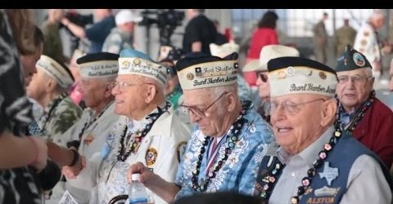

~~~~~~~~~~~~~~~~~~~~~~~~~~~~~~~~~~~~~~~~~~~~~~~~~~~~~~~~~~~~~~~~~~~~~~~
What I posted for my students December 7, 2020:
Our December THEME of HOPE continues.
I hope this note finds my Spanish scholars happy and healthy! I know that learning from home and being online "all the time," isn't fun or the normal that we're used to... We like going outside. We're used to standing on the corner and waiting for the bus. And even when we complain about having to go to school, we enjoy being in the company of our friends, our teammates, and even the teachers who make awful jokes or silly puns! It's the life we love and we're not living it right now. It's not normal, but imagine for a moment if that was your normal! Imagine if your entire world experience had to be lived from inside looking out... What would that be like? Let's go ON THE ROAD and meet a little boy who is "stuck at-home and not allowed to go outside and play and interact lest he get sick!" This is his everyday normal! This is his reality! This is his world! I wonder what you could do to bring the world closer to him? https://www.youtube.com/watch?v=0YA33YxbIDM

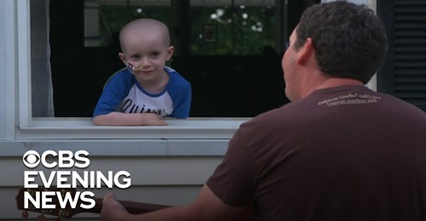

What I posted for my students December 4, 2020:
Our December THEME of HOPE continues.

On December 14, 2012, the Sandy Hook Elementary School shooting occurred. Sandy Hook is in Newtown, Connecticut; not very far from here... 26 people were killed that day. That included 20 children between six and seven years old, and six faculty members. The sadness of that day still gives us reason to tear-up when we think of the innocent lives lost and the families that had to go on with empty chairs at their tables... Steve Hartman visited with the husband of one of the faculty members who was lost that day. He met him ON THE ROAD and the encounter gives us a chance to consider if good can come from terrible things and if somewhere in tragedy, we might find HOPE.
https://www.youtube.com/watch?v=F9yfaTEKkrk

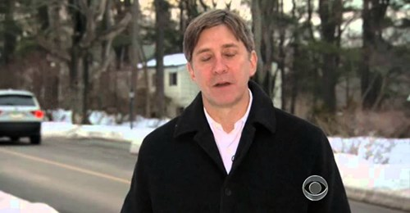

~~~~~~~~~~~~~~~~~~~~~~~~~~~~~~~~~~~~~~~~~~~~~~~~~~~~~~~~~~~~~~~~~~~~~~
What I posted for my students November 30, 2020:
Our New December THEME: HOPE
I thought about what video to use to start our new week, our new THEME, our new way forward. There's always lots to choose from. I do have my favorites! And, I love to discover new ones that speak to our new interests, concerns or “New Normal.” The video I chose is not a typical Holiday video. After a moment into the viewing, you'll understand what I mean. Santa doesn't usually cry... However, I'd like to believe that we all need to experience life and hope in a very special way this year. We are separated, yet closer than we have ever been! We are all experiencing so many different things, hearing so many different opinions, beliefs, versions of reality, interpretations of facts, and predictions of an undetermined future. Yet in the end, it's really all about people doing their best to handle what is cast upon them and find glimmers of HOPE, consolation and the very best of humanity in the simplest gestures of kindness, understanding and support. Santa does that for a little boy who is coming to the end of his very short life. https://www.youtube.com/watch?v=pLbgy_xsYT0

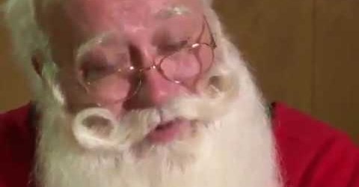

What I posted for my students Wednesday, November 25, 2020:
Tomorrow is Thanksgiving! ¡Feliz día de gracias!
Our world seems to keep on changing this year - virtual to hybrid to virtual again! We find our footing, achieve success and then the playing field changes. So we adjust, and we move on. It's not so bad really. Have you noticed how comfortable we have all gotten with each other? Besides being rich with content and curriculum, our classes are infused with humor and humanity. We know each other; we like each other. Our mindset is focused on doing what we have to do in order to be successful, have an impact and do the right thing! And even in this pandemic, we have all found things to be Thankful for... Today, let's go On The Road and meet someone who was settled into her "New Normal," and was thankful to be away from the danger and threat of the disease. But something triggered within her and made her realize that she had to leave her comfort zone of home and family. Where did she go? What did she have to do? Who needed her more than her family? Go On The Road and find her; and, keep in mind that your Spanish assignment from yesterday is linked to this video...
https://youtu.be/6iI8ZR833NQ

~~~~~~~~~~~~~~~~~~~~~~~~~~~~~~~~~~~~~~~~~~~~~~~~~~~~~~~~~~~~~~~~~~~~~~~~
What I posted for my students Monday, November 23, 2020:
Our Theme of Thanksgiving continues...
I hope you had a good weekend and that you are adjusting to being fully virtual - again! Thank you to those students who are reaching out and offering suggestions and ideas on how best to structure classes and assignments! I am very open to your thoughts, ideas and insights. Your feedback is most welcome. This continues to be new to us and sometimes when things are new we have to go by our instincts! Instincts are interesting things. They reflect who we are, what we've experienced and the wisdom we have earned in life! Let's meet someone who put her maternal instincts to very good use ON THE ROAD: https://www.youtube.com/watch?v=ZItCEOTPvKA&t=8s

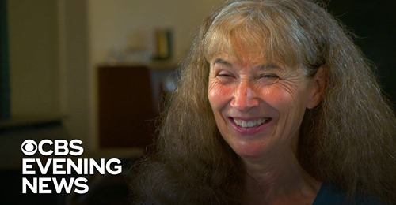

~~~~~~~~~~~~~~~~~~~~~~~~~~~~~~~~~~~~~~~~~~~~~~~~~~~~~~~~~~~~~~~~~~~~~

What I posted for my students Friday, November 6, 2020:

November is the Month of "Giving Thanks." I am sure that even in a pandemic, all of us can find something to be thankful for! Perhaps, even a great many things to be thankful for! I wonder how often we take time to reflect on those things - great or small for which we are truly appreciative. Today, let's restart our November with a sense of "Thanksgiving" for those things or persons or gifts in our lives that that we appreciate. And while we do, let's go On The Road and meet a man who has everything to be thankful for, and the nurse who saw a need and chose to respond with love, compassion and goodness.
https://www.youtube.com/watch?v=BWzXvtlMCs8&t=4s

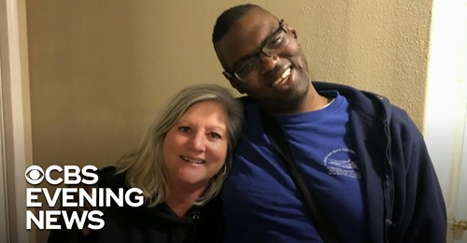

~~~~~~~~~~~~~~~~~~~~~~~~~~~~~~~~~~~~~~~~~~~~~~~~~~~~~~~~~~~~~~~~~~~
What I posted for my students Thursday, November 5, 2020:
So we don’t know who the President will be for the next four years; that is very true! Important people with important titles will be dealing with that drama for some time to come… Time will tell! However, we do know some things for sure. Both President Trump and Vice President Biden ought to be thanked for their willingness to serve, lead and tirelessly work during what used to be called their “Golden Years.” Yes, neither are young! Many their age are retired and have been for quite a few years! So, all politics aside, let’s salute the value of hard work, service, dedication, and sacrifice as we go On The Road today and meet someone who was once “the oldest living worker in the country!” Could it be you someday? Heed what he intones: “Use it or lose it.”
https://www.youtube.com/watch?v=0UDG3k1R8Lc

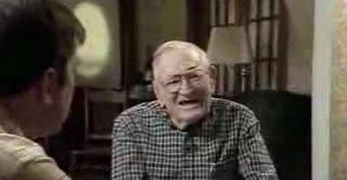

~~~~~~~~~~~~~~~~~~~~~~~~~~~~~~~~~~~~~~~~~~~~~~~~~~~~~~~~~~~~~~~~~~~~
~~~~~~~~~~~~~~~~~~~~~~~~~~~~~~~~~~~~~~~~~~~~~~~~~~~~~~~~~~~~~~~~~~~~~~~
What I posted for my students on October 27, 2020:
What would you do if you heard that someone who you kind of knew had passed away? You know, someone like the grocer who always was there w/ fresh produce, or the bakery lady or the man who greeted you every Saturday or Sunday at the deli, and maybe let you taste things on special occasions? Or how about the guy in the dry cleaners who gave you a new calendar ever December and your clean clothes when you gave him the yellow receipt that your mom had given you to present? Are they important in your life? Does their service, kindness or greeting mean anything to you? Did you look forward to seeing them, or did they look forward to seeing you? Let's go On The Road and pay a visit...
https://www.youtube.com/watch?v=thHoO5JUYQA&t=11s

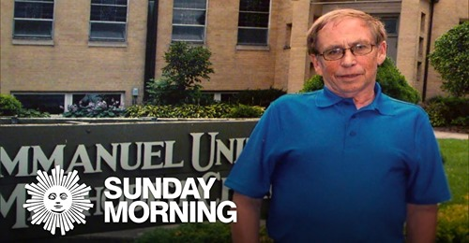

What I posted for my students today, Friday, October 30, 2020:

What will we do next week when the Presidential election is over? No more signs on lawns. No more TV "experts" telling us who to vote for. No more phone calls from strangers asking us who we'll be voting for. No more family arguments over who is the best/worst candidate. No more radio commercials or internet advertisements or people coming to our doors with printed material that we promise to read, but perhaps just pile up on the kitchen table! Yes, what will we do? Perhaps, we'll do what we always do... We'll go on! The clocks will keep ticking. The school bells will ring. Government will continue. Parents will parent. Teachers will teach. And America will be America! Once upon a time, that America was referred to as a "Shining City on a Hill." And for all of us in whatever way we define it, when we hear the notes of that special music played On The Road today, may we all bask in the glow of that Shining City and be at Peace!
https://www.youtube.com/watch?v=Hr4Jq4z58_c

~~~~~~~~~~~~~~~~~~~~~~~~~~~~~~~~~~~~~~~~~~~~~~~~~~~~~~~~~~~~~~~~~~~~

What I posted for my students for Monday, October 26, 2020
Happy Monday and Welcome back "in the flesh," to some of my 7th grade students! Your presence this Monday - Tuesday is a wonderful sight to behold... More students will return on Thursday - Friday! Some will remain virtual for a while longer and that will be fun, too. It's all part of our New Normal. And in spite of the unique challenges we have all faced, have you noticed that teaching and learning are taking place? We're even enjoying ourselves. You've even been caught laughing at silly jokes and corny puns in class! And even though a screen has divided us for what seems like an eternity, friendships have begun, relationships have endured, and our sense of community has been recognized as being "alive and well!" And if that isn't grand enough, it will soon be Halloween! So, in the spirit of the season, let's go On The Road and meet a little boy who was very alone during this pandemic and found a friend in a most unusual mate.... And perhaps we can be grateful that the friendships we have sustained and the new relationships we have forged are a bit more lively, human and real than the "bones "of a friendship made real by a little boy who just needed to not be so alone anymore!
https://www.youtube.com/watch?v=XNfxOR3gOPs

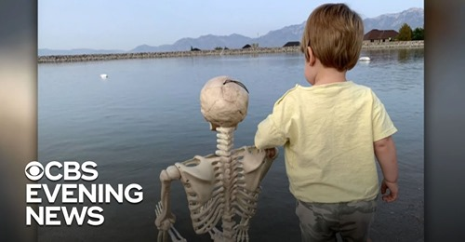

~~~~~~~~~~~~~~~~~~~~~~~~~~~~~~~~~~~~~~~~~~~~~~~~~~~~~~~~~~~~~~~~~~~

What I posted for my students for Thursday, October 22, 2020:
Reminder: Please review the On The Road videos that we have viewed and discussed over our past 25+ meetings. Each has a special message. Each tells a very human story of some people who are not all that different from us! Which story or stories has had an impact on you thus far this year? Which one comes to mind first? "Wonder why?" What does it say about that story? What might it being saying about you? Review. Reflect. I know that this is "work." But work is a good thing. Isn't it? Let's go On The Road and consider a work ethic that was born of a different age, but might have a message for us in how it is still being lived.
https://youtu.be/IkB4BLD-Kn4?t=1

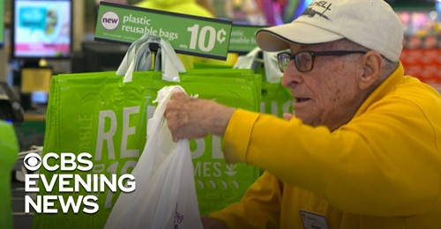

~~~~~~~~~~~~~~~~~~~~~~~~~~~~~~~~~~~~~~~~~~~~~~~~~~~~~~~~~~~~~~~~~~~
What I posted for my students Thursday, October 15, 2020:
What happens when you know that you did something wrong and you just can't shake that guilty feeling? For some people, they go to great lengths to "make right a wrong," even if that poor decision or bad action happened a long time ago... Today, we're going On The Road to experience something that you may have never witnessed before! However, try to see through the uniqueness and "cuteness" of the action. Instead, dare yourself to understand what motivated the actions of these gentlemen and why they are trying to make amends.
https://youtu.be/n-aDuNKSvio?t=7

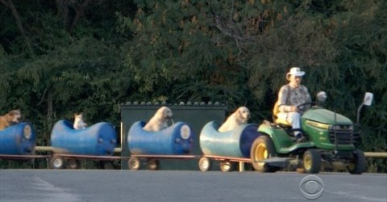

~~~~~~~~~~~~~~~~~~~~~~~~~~~~~~~~~~~~~~~~~~~~~~~~~~~~~~~~~~~~~~~~~~~~~~~~
What I posted for my students on Friday, October 9, 2020:
Someone recently posted a patriotic reminder on Facebook that the Vietnam War ended 45 years ago. The post inspired us to remember and thank our fallen warriors whose lives were cut short in a far off country in a war that many want to forget, and that history has yet to fully define. When I tell people that I remember the war, I sound old. But, I do remember it! Walter Cronkite brought it into my little house in the Bronx every night at 7:00pm. But my memories are those of a spectator. Others have memories that were born out of being there! For them, the war has neither fully ended nor has their healing been complete... Let's go On The Road and meet a group of these soldiers as their journey of healing finally ends their war and brings them home.
https://www.facebook.com/OnTheRoadCBS/videos/448712669260572

~~~~~~~~~~~~~~~~~~~~~~~~~~~~~~~~~~~~~~~~~~~~~~~~~~~~~~~~~~~~~~~~~~~~~~~~~~~~~~~~~~~~~

What I posted student for my students on Thursday, October 8, 2020:
I'd like to honor the school custodians today. Why? Because they are the unsung heroes who make our school community warm-n-cool, functional, stocked and sparkly clean. And in a special way this year, they ensure our health and safety in COVID related ways. Always there for us to answer a need or point us in a direction, they always seem to hold the "keys" literally and figuratively to our School Life! Now, let's go ON THE ROAD and meet a special custodian who reminds us that WISDOM comes from experience and love and all we have to do is to be open to it:
https://www.youtube.com/watch?v=FPVGznxirn4

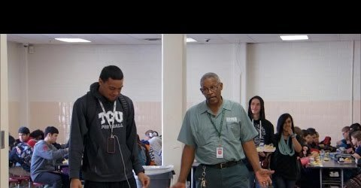

~~~~~~~~~~~~~~~~~~~~~~~~~~~~~~~~~~~~~~~~~~~~~~~~~~~~~~~~~~~~~~~~~

What I posted for my students on Wednesday, October 7, 2020:
I watched the evening news earlier and learned that another innocent man of color was killed by the police. It seems that the victim was attempting to break-up a domestic dispute when the police arrived. Then amid hands being raised and tasers being released, the man who was trying to help fell victim to a rookie's police officer's bullet.
There comes a point when you want to stop believing that such things can still happen. I thought of all those souls who have been lost in similar circumstances. And of course, I thought of George Floyd. I also returned to what I posted back then for my students. Unfortunately, it is still as relevant today as it was all those months ago...
Forgiveness. What is? What does it look like? Would we recognize it, value it, believe it - if we saw it in action? I went to the internet to find this morning's video and I carried with me the weight of these past weeks on my soul. And I wondered what it is that so many in our country need to give and receive in order for healing to begin, reform to take place, and minds to change so George can truly rest in peace... Forgiveness came to mind. Let's go ON THE ROAD and begin that experience together:
https://youtu.be/7wffHBQKq74...7

~~~~~~~~~~~~~~~~~~~~~~~~~~~~~~~~~~~~~~~~~~~~~~~~~~~~~~~~~~~~~~~~~~~~~
What I posted for my students on Tuesday, October 6, 2020:
There's something about dogs that can capture the essence of who we are... They seem to understand us and we in turn - love them for it! Today, let's go On The Road and meet Robby. He loves dogs, too. But the dogs that he reaches out to are old and unwanted. Some aren't very pretty or cute, many are past their "prime." Why? What is it about those dogs? Or, what is it about Robby? What might it be teaching us???
https://www.youtube.com/watch?v=8usTqFv-MjU

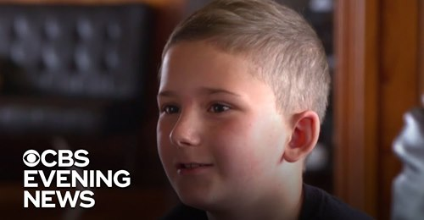

~~~~~~~~~~~~~~~~~~~~~~~~~~~~~~~~~~~~~~~~~~~~~~~~~~~~~~~~~~~~~~~~~~~~

What I posted for my students on Friday, October 2, 2020:
It's raining! Don't you hate getting wet, having your activities canceled or being stuck inside! Imagine so much rain that you can't even stay inside because the water levels have gotten so high your house might flood, be carried away, or collapse! When that happens, families can lose everything that they have worked for their entire lives! And many of them are just grateful to be alive and not to have lost loved ones!!! When the initial shock has passed, they realize that they must “go on...” But, how? And who will help them in the process? Let's go On The Road and meet someone who answered the call to help those in need.
https://youtu.be/rQVC_m4GtDs?t=11

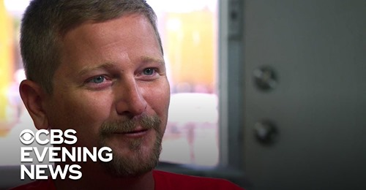

~~~~~~~~~~~~~~~~~~~~~~~~~~~~~~~~~~~~~~~~~~~~~~~~~~~~~~~~~~~
What I posted for my students September 24, 2020:

Today's weather is perfect for being back at school and practicing football! It's like this every year and football is always there ready to be played! Of course, this year is different. Social distancing and our "New Normal" has hampered a great many of the fun things we like to do. We have to be careful. We have to "play it safe," before we can play football! But there's more to life than football - even for college and professional football players! Let's go On The Road today and meet someone who defines himself in more ways than the number of plays he can do on the field!
https://www.youtube.com/watch?v=spUXAZp5sQ4

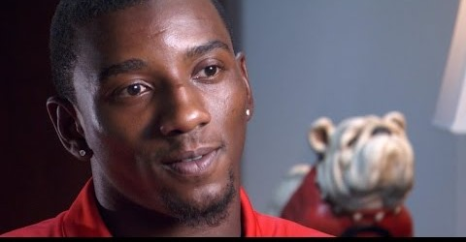

~~~~~~~~~~~~~~~~~~~~~~~~~~~~~~~~~~~~~~~~~~~~~~~~~~~~~~~~~~~~~~~~~~~~~~~~

What I posted for my students on Wednesday, September 23, 2020:

Yesterday was National Voter Registration Day! It reminded us once again, that an Election Day will soon be upon us. Campaigns can be exciting and informative. They can also be unkind, misleading and uncivil. Let's go On The Road today and be part of a campaign-election experience that reminds us that's it's OK to have different opinions about what we need to go forward as long as we remember to respect each other and allow civility to anchor our character.
https://www.youtube.com/watch?v=LjRrg-FytMA

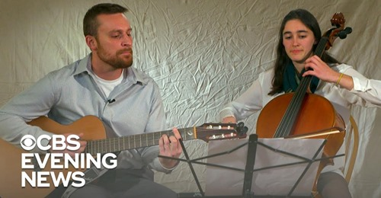

~~~~~~~~~~~~~~~~~~~~~~~~~~~~~~~~~~~~~~~~~~~~~~~~~~~~~~~~~~~~~~~~~~~~~~~~
What I posted for my students September 22, 2020:
Weddings can be wonderful events. In fact, my son was married on Saturday! The happy couple looked great. They were all smiles and had that special glow that people sometimes talk about... They probably didn't even notice that because of the pandemic, the majority of their family and friends weren't there. Their BIG wedding had been postponed from May and then scaled down to just their bridal party and few others who were part of their "safe circle." It didn't matter. It was their Fairy Tale and it had come true. And it reminded me of another wedding with another bride whose fairy tale day continued to live on in the life of a special little girl who saw her as her very own Cinderella! Let's go On The Road be part of their story and wonder what it could be teaching us!
https://www.youtube.com/watch?v=aycd3bVRmcU&t=4s

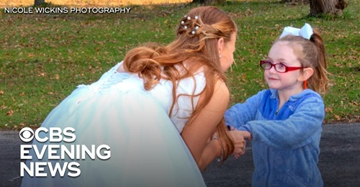

~~~~~~~~~~~~~~~~~~~~~~~~~~~~~~~~~~~~~~~~~~~~~~~~~~~~~~~~~~~~~~~~~~~~~~~
What I posted for my students September 16, 2020:
Our year is well under way. You are already used to the routine even within our "New Normal." Teaching and Learning are taking place. Homework is being assigned. Quizzes and tests have been planned and executed. Parent phone calls have been made, questions asked-n-answered, and summer already seems like it was a long time ago... Some students even think that they have their teachers "figured out." But, do they? Perhaps when it comes to teachers - just like with their curricula, there's lots of layers to be discovered. And just maybe, no one ought to jump to conclusions. Let's go On The Road today and meet someone who just might surprise you!
https://www.youtube.com/watch?v=8w-fduifHII&t=14s

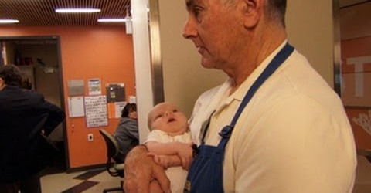

~~~~~~~~~~~~~~~~~~~~~~~~~~~~~~~~~~~~~~~~~~~~~~~~~~~~~~~~~~~~~~~~~~~~~~~~

~~~~~~~~~~~~~~~~~~~~~~~~~~~~~~~~~~~~~~~~~~~~~~~~~~~~~~~~~~~~~~~~~~~
What I posted for my September 14, 2020:
Someone once told me that: "CHARACTER is Who YOU are when NO ONE is Watching!" You are Middle Schoolers. You are used to "being watched!" You are supervised in halls, on the bus, in the cafeteria, etc. But when no adult is around, are you different? Do you behave differently? And what would your parents say, think, or consider "if they only knew?" Today, let's go On The Road with some Middle School students who weren't being watched, and who showed who they were by how they acted and the goodness that they shared... https://www.youtube.com/watch?v=RmQczPAz5Os&t=36s

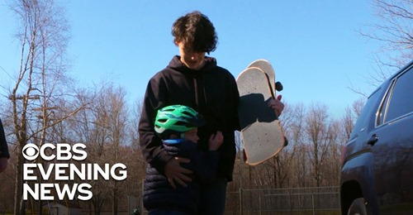

What I posted for my students September 11, 2020:

Some events need explanation or description. Some events need intense debate, dialogue, recollection, research or review... For Americans and New Yonkers in particular, one event just needs a numeric identifier: 9-11.
https://www.youtube.com/watch?v=RArsQ5tCed0
Remember.

~~~~~~~~~~~~~~~~~~~~~~~~~~~~~~~~~~~~~~~~~~~~~~~~~~~~~~~~~~~~~~~~~~~

What I posted for my students September 9, 2020:
Classes are more than just a random group of students piled together for convenience for all to experience a certain course of study. Classes are an opportunity to make friends, forge lifelong bonds, develop community, and experience a sort of "home and family" away from your own home and family! Today, let's go On The Road and meet two little girls who found more than friendship. They found each other! They declared themselves to be "twins," and in so doing - perhaps, they offered an example to us all... Watch. Reflect. Consider.
https://www.youtube.com/watch?v=-x90tR8-g5o

~~~~~~~~~~~~~~~~~~~~~~~~~~~~~~~~~~~~~~~~~~~~~~~~~~~~~~~~~~~~~~~~~~

What I posted for my students for our First Day of Classes, September 8, 2020:

Summer is over, but it's still hot! School has begun, but we're still home and learning from our computer... We have new teachers, some new classmates, new expectations, new apprehensions, new questions and wonderings, new fears and anxieties, new excitement and energy! For some of us, this is easy. For others of us, this is a real challenge! However, as the following video reminds us - we can all fit in and transition to a new school year if we just remember to be kind and supportive to each other!
https://www.youtube.com/watch?v=BdtiW2UDfD0

