Newburgh ECSD 2017 Flexible Spending Account Open Enrollment Instructions
Once you have logged in, and clicked the Continue to InRoll Benefits Track, the system will let you confirm your contact and dependent information. Once you have confirmed this information, you will move to the Unreimbursed Medical Expenses FSA Election Page.
On this page, you may enter the ANNUAL amount you wish to contribute to this plan. If you wish to decline the benefit, click the Waive Coverage button.
PLEASE NOTE: You must enter the total ANNUAL amount you wish to contribute. The ANNUAL amount you are electing for this benefit will be deducted over 19 pay periods.
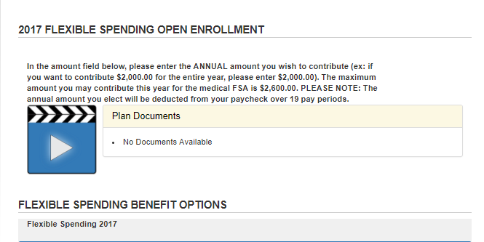
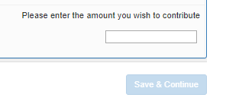
ANNUAL AMOUNT

The next page is for the Dependent Care FSA Plan. On this page, you may enter the ANNUAL amount you wish to contribute to this plan. If you wish to decline this benefit, click the Waive Coverage button.
PLEASE NOTE: You must enter the total ANNUAL amount you wish to contribute. The ANNUAL amount you are electing for this benefit will be deducted over 19 pay periods.

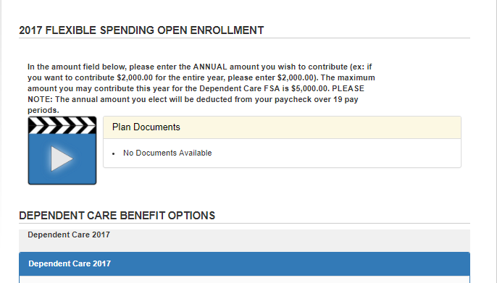

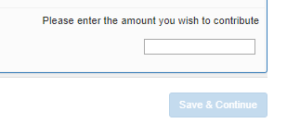
ANNUAL AMOUNT

On the final page, you will review your enrollment elections, and click the green Sign and Complete Enrollment button.
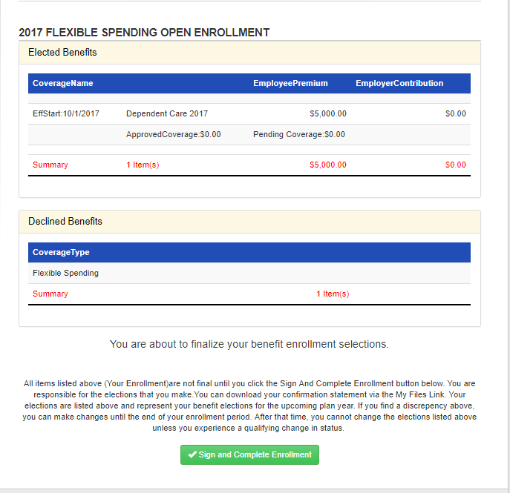
ANNUAL AMOUNT WILL BE DEDUCTED OVER 19 PAY PERIODS

