Newburgh ECSD
Employee Enrollment Guide

Your Enrollment
Newburgh ECSD employees can use the Newburgh ECSD Employee Enrollment Guide to become rapidly familiar with the InRoll+ web-based benefits enrollment application. This guide helps Newburgh ECSD employees work through the easy-to-use benefit enrollment procedures.

The Newburgh ECSD Employee Enrollment Guide helps you complete the enrollment sections:
- Registering, if you are a new InRoll+ user
- Benefits selection (including waiving coverages)
- Confirmations–Print a copy or display a listing of your elected/declined benefits

Your Secure Information
We build security into each aspect of the InRoll+ enrollment. Each enrollment stage uses rigorous security controls; from the software design to the way we store and transfer your critical personal identifiable information (PII). We secure your information and take multiple actions to ensure your details remain safe.

InRoll, LLC takes these measures to ensure the security of your benefits information:
- Logs each InRoll+ system access by every user
- InRoll+ automatically logs off users after 20 minutes of inactivity
- Scans the system daily and constantly monitor all services
- Manages InRoll+ 24 hours a day, 365 days a year using a global security team
- Encrypts all personal information to prevent any unauthorized access
- Authenticates your identity to ensure only you can access your information
- Requires our data centers to meet and exceed all industry and government requirements
- Backs up your data across multiple data centers to protect it against data loss

New User Registration

Step 1
Using Google Chrome or Mozilla Firefox browsers, type the address in your preferred browser:
https://www.InRollplus.com

Click the User Login button and the InRoll+ Log-in web page displays.

Step 2
In the New User? Section of the InRoll+ Log-in web page, type in the fields:
- Your Last Name
- The Last Four Digits of SSN (Social Security number)
- Your Date of Birth (MM/dd/yyyy format) Click the Register button.
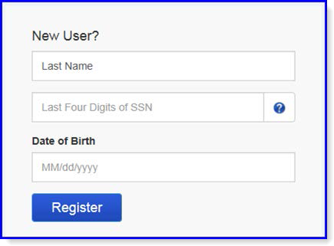

Step 3
On the InRoll+ Create Your Account web page, complete these fields:
- Account Password
Note: Check the requirements to make your InRoll+ password very secure.
- Confirm Password for the account
- Two different Security Questions selected

The Question 1 Answer and Question 2 Answer

Click the Register button.

Note: InRoll+ generates the User Name. You can ask your administrator to change your User Name. A
User Name must exceed four characters.

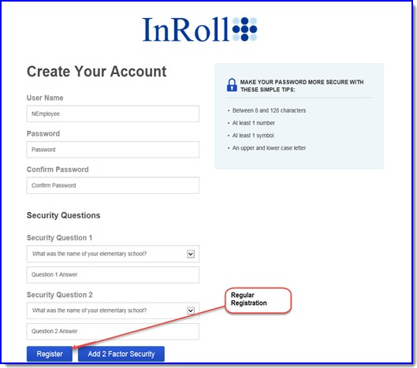

Selecting Benefits

Step 1
On the InRoll+ Welcome web page, click the green Click Here to InRoll button.

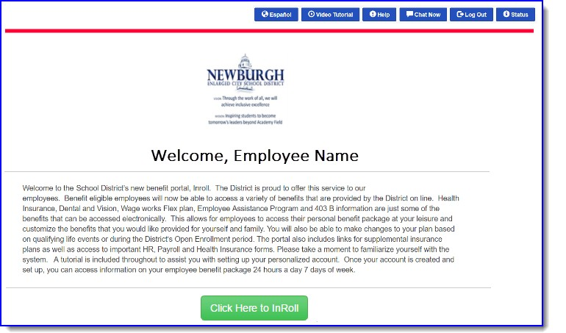

Step 2
On the My Benefits web page, the You have no current elections message displays. Click the blue Continue to InRoll Benefits Track button.

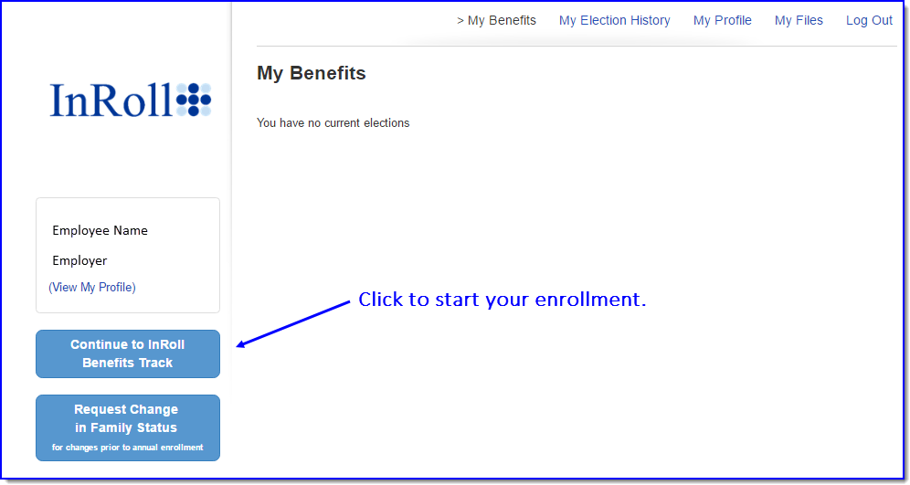

InRoll+ My Enrollment Web Page
The My Enrollment web page displays and you’re ready to begin enrollment.
This My Enrollment web page helps you select your participation in all benefit plans. You continue to return to this web page after you elect coverage for each benefit or waive coverage of that benefit.
Note: You only see benefit information that meets your eligibility, such as new hire enrollment, open enrollment, or Change of Family Status enrollment.

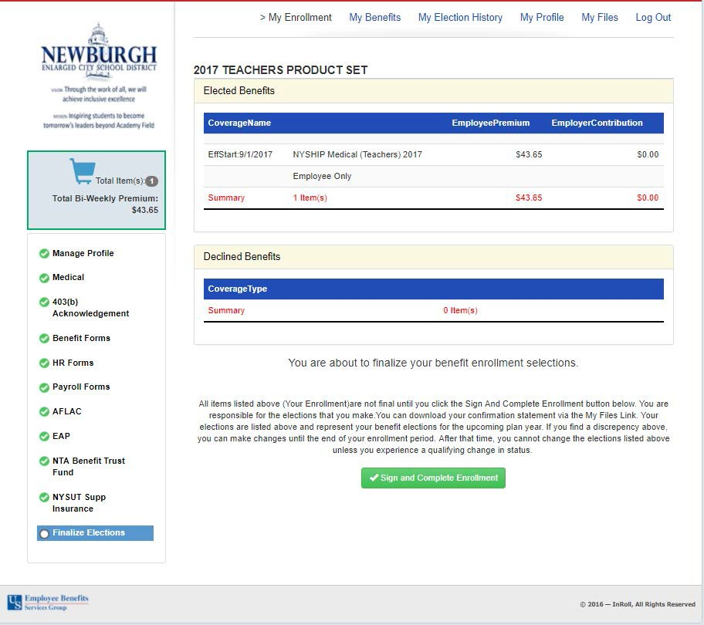

Note: For each benefit, InRoll+ immediately saves your choices when you click the Save and Continue
button or the Waive Coverage button.

Step 3
  - Click the Manage Profile link (see InRoll+ My Enrollment Web Page on page 7) in the list of benefit plans (left pane).
  - Complete any required changes on the Manage Profile web page. Navigate through the Demographics, Occupation, Emergency Contacts, and Dependents dialog tabs. Example changes:
    - Update your employee information
    - Add a dependent or spouse
    - Update your occupation information
  - Save your Profile.

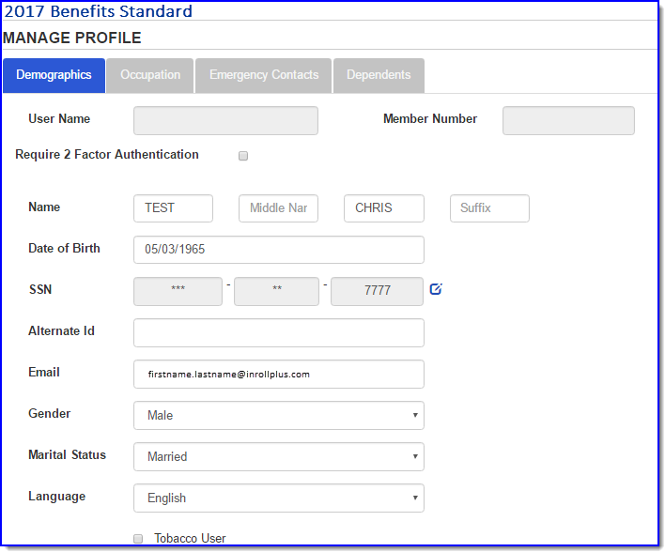

Step 4

- Select any desired benefit plan listed (this can be any product plan such as the Long Term Disability Benefit Options example). You can also display any plan video or plan documents.
- For some benefit plans you must:
  - Select the waiting period associated with the plan
  - Select the amount of desired coverage from a selection list
  - Input in a field the amount of money you want to contribute towards the benefit

- Once you have selected your plan options, click the Save & Continue button.

- When you want to decline benefit coverage, click the Waive Coverage button.

Step 5
- Select all other benefits that your employer offers using the links on the left navigation panel.
Note: Your employer can decide in what order that you work with your benefit plan selections.
- Continue with the benefits list until you elect or waive coverage for each benefit.

Note: The Sign and Complete Enrollment button is at the bottom of the Elections Review
Step 6
- InRoll+ displays on the Elections Review web page the selected benefits and the contribution details, followed by the benefits you declined.
- Before clicking the Sign and Complete Enrollment button, consider:
  - You are responsible for the benefit elections.

  - All elected benefits listed are not final until you click the Sign and Complete Enrollment
button.

  - You can send your confirmation statement to your device by using the My Files link. (See InRoll+ My Enrollment Web Page on page 7.)

  - The elections listed on the confirmation statement represent your benefit elections for the
upcoming year.

  - If you find any discrepancy in the elected benefits, you can still make changes before your enrollment period ends.

  - Once the enrollment period finishes, you can’t change the benefit elections, without experiencing a qualifying life event.

Confirmation Statements

Step 1
- Click the Sign and Complete Enrollment button to finish your enrollment.

- InRoll+ confirms you completed your enrollment. InRoll+ instructs you how to obtain a printed Confirmation Statement.

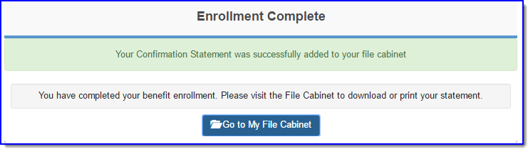

Step 2
- For a printed confirmation statement, click the My Files link on the InRoll+ My Enrollment web page. (See InRoll+ My Enrollment Web Page on page 7.)

- Click the Download button to the right of the Confirmation Statement Description you want to send (Download) to your device. You can display or print the statement.

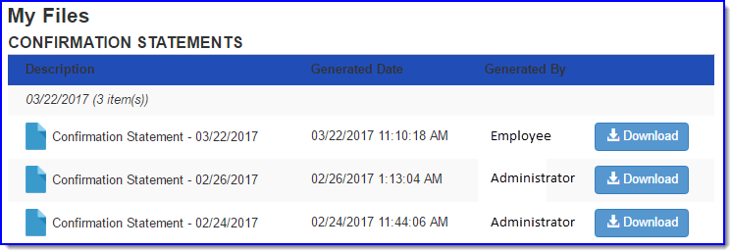

Step 3
A. To display your elected benefits online, click the My Benefits link on the InRoll+ My Enrollment
web page. (See InRoll+ My Enrollment Web Page on page 7.)

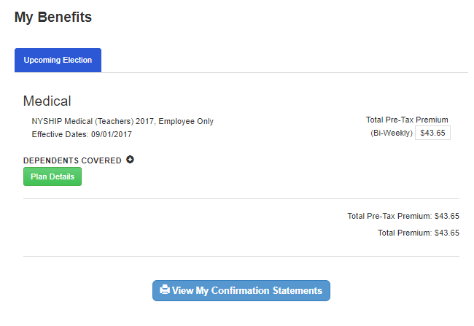

For Help and More Resources
Click the Help button or the Chat Now button in the top-right corner of the InRoll+ web page when you can’t find the answer in the Newburgh ECSD Employee Enrollment Guide.

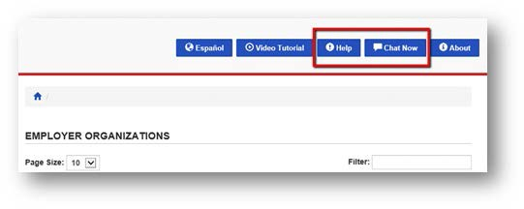

Help
Click one of the following buttons in the upper-right corner of the web page:
- Email a Question–when your request does not require immediate assistance.
- Chat Now–Click the icon for immediate help; works the same as the Chat Now button.
- FAQs (Frequently asked questions):
- Log In–Information to log in and register your new user account
- Enrolling–Your stored documents in the My Files web page (including confirmation statements)
- My Benefits–Displays details about your elected benefits
- Submit Feedback–Rate your experience with our InRoll+ application by providing comments.

Frequently Asked Questions

Do you provide online enrollment for open enrollment and ongoing enrollment?
Yes. The employees can enroll throughout the Open Enrollment period. After that, employees can enroll if they are a new hire, or if they qualify for a forced Open Enrollment by HR because of a Change of Family Status (COFS). InRoll+ derives New Hire Enrollments from the hire date of each employee. InRoll+ displays an Open Enrollment window for a new hire based on the Hire Date. InRoll+ uses the enrollment dates that an Employer provides when determining the Open Enrollment window. InRoll+ can change the dates anytime at the client's request.

Can you distinguish between new hire enrollments and current employee changes?
InRoll+ calculates the benefit dates based on the employee hire date and benefit rules. InRoll+ directs the employee to the appropriate enrollment web page—new hire, annual enrollment, or COFS.

How does InRoll+ regulate the appropriateness of a family status change?
InRoll+ sends email alerts to your Employer to approve change requests. The Employer HR department can approve or decline each request, based on the provided documentation.

Does InRoll+ generate a confirmation statement?
Yes. InRoll+ can download confirmation statements to your device to store and print.

Is an employee Social Security number (SSN) visible on the employee web page?
No, we protect employee privacy by showing only the last four digits of the SSN for confirmation purposes on the enrollment web page and in the InRoll+ reports.

What languages does InRoll+ support?
English and Spanish are the two supported languages. InRoll+ converts between the two languages using a single mouse click; it converts text, audio, and video.

Why do I sometimes see an invalid address notification from InRoll+ when I type an employee address?
The InRoll+ system performs real-time address validation with the U.S. Postal Service. The validation helps prevent InRoll+ from storing incorrect addresses.

Can an employee change their Social Security number (SSN) in InRoll+?
No. The employee cannot change their Social Security number. However, they can change their address and phone number.

Is there a default password for each new user to access the InRoll+ application?
For security, there is not a default password. Each employee must use a combination of personally identifiable information, known only to them. The personal information consists of your last name, date of birth, and the last four digits of your Social Security number.

Can an InRoll+ administrator lock a member out of their account?
An InRoll+ administrator locks a member’s account when an employer terminates an employee, or a user exceeds the maximum number of permitted log-on attempts.

Does InRoll+ require a newborn child to have a Social Security number before adding the dependent to a member?
No. However, once you obtain your dependent’s SSN, you must enter the SSN in InRoll+ as soon as possible.

How many years of medical election history does InRoll+ store?
InRoll+ can store five years of medical election history.

